DRAFT
IFAD- WEST AND CENTRAL AFRICA DIVISION
Contributors:
Ulrich Kleih, NRI, University of Greenwich, UK
Eddie Addo-Dankwa, GASIP, MOFA, Ghana
Patrick Kojo Ofori, GASIP, MOFA, Ghana
Pius Sanyare, GASIP, MOFA, Ghana
Edwin Ahumah Fayorsey, GASIP, MOFA, Ghana
Adama Ayueboro, MOFA, Accra, Ghana
Cecilia Adomah-Yeboah Junior, MOFA, Sunyani, Ghana
Ofosu Dankyira John, MOFA, Sunyani, Ghana

Large Grant Agreement: 2000000473

Increasing Performance of the Cassava Industry in West and Central Africa Region (IPCI)

Cassava Value Chain Analysis in Brong Ahafo, Ghana
Final Draft, March 2017

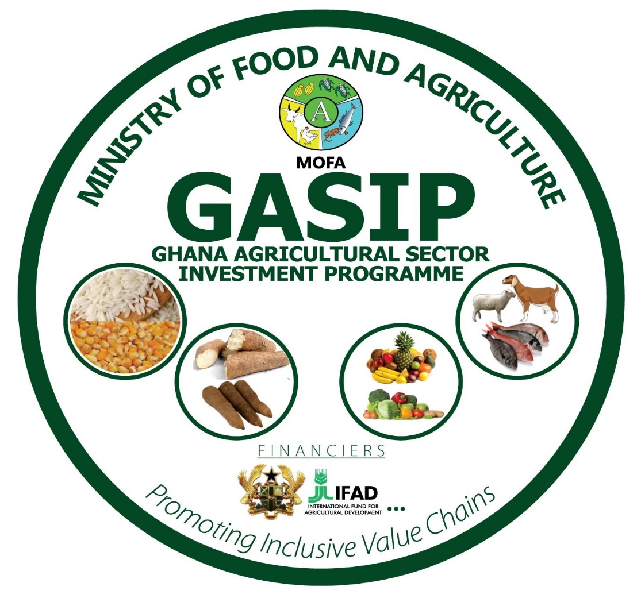
Table of Contents
Acknowledgements 4
Summary and Recommendations 5
Introduction 9
Background to study 9
Problem statement 9
Objectives of assignment 9
Methodology 9
Fieldwork 11
Brong Ahafo Region 12
Mapping of the Value Chain – Functional Analysis 13
SWOT analysis of key products 16
Governance of the Cassava Value Chain 19
Options for upgrading the value chain 20
Selected Results of the Value Addition Calculations 21
Key findings 22
Performance of the value chain 25
Social and environmental impacts of value chain upgrading 25
Appendices 28
Appendix 1: References 28
Appendix 2: Checklists for fieldwork 30
Appendix 3: People and organisations met in Ghana 48
Appendix 4: Components of Pilot Model to Calculate Value Addition of Cassava Value Chain in Brong Ahafo 53
Appendix 5: Selected slides of presentation at GASIP Offices, May 2016 75

Acronyms
ABSD | Agribusiness Support Division
AEA | Agricultural Extension Agent
BAC | Business Advisory Centre
BAR | Brong Ahafo Region
C:AVA | Cassava: Adding Value for Africa project
CEO  CF | Chief Executive Officer  Commercial Farm
CRI | Crops Research Institute, CSIR
CSIR | Council for Scientific and Industrial Research
DFID  EDAIF | UK Department for International Development  Export Development and Agricultural Investment Fund
FAO | Food and Agriculture Organization of the United Nations
FRI | Food Research Institute, CSIR
GAPs | Good Agricultural Practices
GASIP | Ghana Agricultural Sector Investment Programme
GCCE | Ghana Cassava Centre of Excellence
GhC  GPC | Ghanaian Cedi  Good Practice Centre
Ha  HQCF | Hectare  High Quality Cassava Flour
IFAD  IGS | the International Fund for Agricultural Development  Intermediate Goods and Services
IPCI  LS | Increasing Performance of the Cassava Industry in West and Central Africa Region project  Large-scale Farm/Estate
MOFA | Ministry of Food and Agriculture
NBSSI | National Board for Small Scale Industries
NRI | Natural Resource Institute, University of Greenwich
PHC  PROVACA | Population and Housing Census  Cassava Value Chain project, Kumasi based
RDA | Regional Director of Agriculture
REP | Rural Enterprise Programme
RTIMP  SDC  SH  SME | Root and Tuber Improvement and Marketing Project  Swiss Agency for Development and Cooperation  Smallholder Farmers  Small and Medium-scale Enterprises
T  USD  WAAPP | Metric tonne  United States Dollar  West Africa Agricultural Productivity Project
WVI | World Vision International
ZM&ES | Zonal Monitoring and Evaluation Specialists
ZVCS | Zonal Value Chain Specialists

Exchange rates (May/June 2016): USD 1 = GHC 3.9

Acknowledgements

The authors would like to thank all those who have contributed to this study in one way or another. In particular, thanks are due to the many farmers, traders, processors, Government representatives and NGOs, who have provided information and given their time. We are grateful to colleagues from GASIP, MOFA, IFAD, and NRI for their advice.

Last but not least we would like to thank the International Fund for Agricultural Development (IFAD) for providing the funds for undertaking this study, however the views expressed here are not necessarily those of IFAD.

Summary and Recommendations

This cassava value chain analysis has been carried out in May and June 2016 in Brong Ahafo Region, Ghana, as a joint initiative of the IFAD supported Ghana Agricultural Sector Investment Programme (GASIP) and the Increasing Performance of the Cassava Industry in West and Central Africa (IPCI) project. The objective was to gather cassava value chain related data and pilot a methodology to analyse the data with a view to undertake similar analyses in other parts of the country.

The emphasis of the study was on cassava root production, gari processing, and wholesale trading of fresh cassava roots. The methodology employed in this study draws on value chain analysis and elements of the ‘filière’ approach. The indicators calculated include value of production, processing, and trading; use of intermediate goods and services (IGS); value addition in terms of land, labour, financial resources use, taxes and duties, and generation of profit margins. Equity considerations have been taken into account by comparing labour inputs with profit margins in selected parts of the value chain. Depreciation of investments have been analysed where applicable. Factor cost ratios have been calculated in order to assess the performance of the value chain.

The Brong Ahafo Region is one of the ten Administrative Regions of Ghana. It has a total land area of 39,557sqkm, covering 16.6% of Ghana’s total land area. The population stood at 2,310,983 in 2010. The Region is well endowed with natural resources and considered the bread basket of the country, in that it produces approximately 30% of the country’s food requirements. The Brong Ahafo Region was selected for the study because it ranks as one of the highest cassava producing regions in the country. The study team interacted with Regional and District Agricultural Officers, cassava producers and processors, input dealers, aggregators, and traders.

Results of the analysis show to what extent the cassava value chain plays a major role in the region’s economy. The value of cassava root production alone is estimated at GhC 1112 million (based on May 2016 prices and official production estimates), whilst the entire chain comprising roots production, gari processing, and wholesale trading has a value of approximately GhC 2 billion. This includes GhC 144 million in the form of imported intermediate goods and services (e.g. fuel or equipment), and GhC 30 million for remaining local IGS (e.g. input supplies). Cassava yields obtained from farmers during the survey have been slightly higher than official figures, which has been taken into account.

The main components of value addition are labour and profit. For example, at production level (of cassava roots), it is estimated that labour income within the branch of the value chain covering small-scale farm production is GhC 949 million, compared to a total smallholder cassava production value which is GhC 1157 million (based on yields of 8 tonnes per acre). At the same time, this would leave smallholders with a negative profit margin if they were to employ hired labour for their cassava root production, or it would mean that they value their labour inputs (opportunity cost of labour) below the rate on the labour market (i.e. at GhC 12 – 13 per day compared to GhC 15 per day).. It should be mentioned that the labour inputs indicated by farmers during the field survey were quite high. To some extent this was due to intercropping practiced in the fields, and some of the labour inputs required for the second crop (e.g. maize or yams) have been allocated to cassava.

For a small-scale farmer producing cassava on one acre of land, this would mean that the value of production (i.e. GhC 1920) has to be compared to intermediate goods and services (e.g. for planting material or transport of fresh roots) valued at GhC 735, and value addition of GhC1390 (i.e. GhC 1290 for hired labour or opportunity cost of family labour, plus GhC 100 per acre for land rental), leaving them with a negative profit margin of GhC -205 per acre. The value of cassava roots is based on a yield of eight tonnes per acre and the price of cassava roots is based on GhC 240 per tonne (i.e. sales price of roots, or cassava consumed by the family at home, valued at price in May 2016). If the IGS is broken down into its components (e.g. transport of roots broken down into means of transport, fuel, labour, and profit of transport enterprise), then the overall profit margin within the smallholder production part of the value chain would be close to zero (i.e. GhC –1.35 per acre).

Assuming a yield increase from eight tonnes per acre to 12 tonnes per acre at smallholder level (due to use of improved planting material, and good agricultural practices) would lead to a value of production of GhC 2880 per acre, and a positive profit margin of GhC 112 per acre. If the calculation includes a break-down of intermediate goods and services (IGS) then the profit margin becomes GhC 388 per acre, leading to an overall profit margin for the entire region of the order of GhC 234 million.

Commercial farms have a higher profitability (i.e. estimated at GhC 974 per acre) due to more efficient production methods, however their overall contribution to cassava production is rather limited (i.e. estimated at GhC 114 million, assuming that new production sites in districts such as Atebubu-Amantin have come into production).

Gari processing is a lucrative business which shows in the field (almost every village has a gari processing association) and in the calculations. Whilst a single small-scale gari processing operation (e.g. a mechanised grater, one or two presses, and about half a dozen frying stoves shared by a group of women) can generate a total output of GhC 280,000 per annum (2 tonnes per week, or 100 tonnes p.a. valued at GhC 2800 each), GhC 118,898 of this is profit, GhC 39,615 goes to labour inputs, and GhC 114,300 to raw material (i.e. fresh roots). The remainder goes into relatively small amounts of imported or local IGS, financial charges, or taxes and duties to be paid by the enterprises.

Medium-scale facilities have a larger throughput (e.g. 3.5 tonnes of output per week, or 175 tonnes per annum), more infrastructure (e.g. solid buildings), and a professional management. It is estimated that such an enterprise can generate a net profit of GhC 1904 per week. Taking into account a break-down of intermediary goods and services, the total profit margin for such an enterprise would be GhC 112,412 per annum, or GhC 674,471 for the entire region. This assumes that only six of these medium-scale facilities are currently in operation and ten in the future.

Cassava trading has been analysed for wholesale traders, who are assumed to trade a quarter of the output of roots either within Brong Ahafo, take it to other parts of the country, or sell it in neighbouring countries. If one wholesale trader has a throughput of six tonnes of cassava roots per week (300 tonnes per annum) the annual value addition for one cassava wholesale trading operation is estimated at GhC 35,189 profits (including those of transporters), GhC 14,131 for labour, GhC 1,838 for financial charges and GhC 8,430 for taxes and duties. This leads to regional figures of cassava wholesale sales of GhC 530 million, GhC 52 million for labour inputs, and GhC 129 million for profit margins. The latter would also account for the traders’ time spent in undertaking their business. It has been assumed that at present traders incur a physical loss of 5% of roots traded. A reduction of the loss figures to zero would mean increased sales and profit margins for the wholesale traders (GhC 556 million and GhC 156 million respectively, for the region), assuming the costs would remain the same.

The overall results show that substantial gains in value addition can be achieved if efficiency within the value chain can be improved (e.g. higher yields as a result of improved planting material and good agricultural practices; improvement of conversion ratio in gari processing from 21% to 25%; and reduction of losses in the trade of fresh cassava roots from 5% to 0%). As a consequence, the total value of the cassava value chain in the region would go up from about GhC 2 billion, to GhC 2.84, including value addition and intermediate goods and services.

Factor Cost Ratios (FCR) have been calculated in order to calculate the performance of the value chain. This performance indicator has been used, given that calculations have primarily been undertaken at market prices and not at shadow prices. The cassava value chain can be considered as efficient in that the output minus tradable (i.e. imported) inputs is greater than the cost of domestic resource factors (i.e. land, labour, and financial resources). The FCR is 0.68 for the current situation, and an FCR of 0.60 is achievable if the aforementioned value chain upgrades are implemented. Other efficiency or performance indicators (e.g. Domestic Resource Coefficient) can be calculated if some of the calculations are made with shadow prices or opportunity costs (e.g. for labour inputs).

A sensitivity analysis based on a 20% reduction of all output prices (given that the cassava root and gari prices were relatively high in May/June 2016) shows that cassava would still play an important role in the economy of Brong Ahafo, in that the cassava value chain would be worth GhC 1.6 billion and it is possible that this would go up to GhC 2.27 billion if the aforementioned value chain upgrading measures were to be implemented. At the same time, in the current situation the profit margin would be significantly more negative (GhC – 232 million) in the smallholder production part of the cassava value chain. An individual small-scale farmer producing on one acre of land would incur a loss of GhC - 589 per acre, if all the labour inputs were to be paid (GhC1290). This means that smallholders would have to put a much lower value on their labour rate (i.e. about GhC 8 per day) compared to the rate on the labour market (i.e. about GhC 15 per day). Profit margins would still be positive for gari processors and cassava root traders, albeit at a lower level. This would lead to a positive overall profit margin in the Brong Ahafo cassava value chain of GhC 114 million in the current situation, and GhC 407 million if the upgrading measures were to be implemented.

The aforementioned analyses have not covered in detail social impacts and sustainability of the cassava value chain (e.g. working conditions, land and water rights, gender and social inclusion, food and nutrition security). Also, no detailed analysis of environmental impacts was undertaken, which includes assessment of resource use (e.g. water, fuel, fertiliser, pesticides), emissions, and impact (e.g. climate change, eco-toxicity, freshwater deprivation).

Recommendations
In view of the above:
- It is recommended to read this report in conjunction with the back-to-office report prepared by the GASIP/MOFA team following the fieldwork in May and June 2016.
- It is recommended that the cassava value chain be upgraded with measures at:
  - production level (e.g. higher yields due to use of improved planting material, and application of good agricultural practices),
  - processing level (e.g. improvement of the gari conversion ratio from fresh roots to final product from 21% to 25%), and
  - trading level (e.g. reduction of losses due to use of better means of transport).
  - The creation or expansion of medium and large-scale enterprises can also make significant contributions to the value chain, requiring inclusive business models whereby smallholder farmers benefit from outgrower schemes to ensure, amongst other things, that the smallholders use quality inputs and that they utilize them in the appropriate way.
- The above upgrading options will require access to finance by different stakeholders in the value chain at production, processing, and trading levels. Requests for financial support need to be backed up with business plans reflecting an enterprise’s or public entity’s capacity to manage the funds to the benefit of GASIP beneficiaries.
- Given that at present no social development experts and environmental analysis specialists are included in GASIP value chain missions, it is recommended that future teams include members with such a background.
- If the current pilot model to calculate value addition in the value chain under different scenarios is acceptable to team members, GASIP, and IFAD, then a full version can be created.

Introduction

Background to study

The Government of the Republic of Ghana has received a loan from the International Fund for Agricultural Development (IFAD) for the implementation of the “Ghana Agricultural Sector Investment Programme – GASIP”. Within its mandate, GASIP planned to recruit a consultant firm or organization, comprising a multi-disciplinary team with competence in agricultural economics and financial intermediation, rural development, environmental economics, climate change, gender issues, development studies, marketing, and any other competence related to value chain analysis, to develop the study “Ghana Inclusive Cassava Value Chain Upgrading Action Plan”.

Problem statement

In particular, the following value chain related issues required addressing:
- What are the value chain drivers and where are the investment points?
- Where are the opportunities for improved value chain governance?
- What are the social and economic impacts of upgrading likely to be if GASIP invests?

Objectives of assignment

The objective of this assignment was to develop a methodology to prepare a pro-poor cassava value chain upgrading action plan. In particular, this involved the following steps:
- Undertake functional analysis of the value chain;
- Identify upgrading options within the value chain;
- Assess how upgrading measures will impact on value chain and livelihoods in the area concerned.
This was undertaken as part of the IFAD supported project “Increasing Performance of the Cassava Industry in West and Central Africa Region (IPCI)”.

Methodology

The methodology employed in this study draws on value chain analysis and elements of the ‘filière’ approach. Value chain analysis (VCA) is a widely applied tool which allows the researcher or development practitioner to analyse the full range of value adding activities in bringing a product or service through the different phases of input supply, production, processing, marketing, and end-use. Amongst other things, it places emphasis on concepts such as governance, innovation, and upgrading a value chain. At the same time, the ‘filière’ approach highlights quantitative relationships within and between sub-sectors participating in the value chain. In particular, the assessment focuses on value addition and how this is affected by changes (e.g. upgrading activities) within the value chain. Equity considerations can be analysed by comparing labour inputs with profit margins in selected parts of the value chain.

A list of references is included in Appendix 1, giving an overview of selected value chain and ‘filière’ literature (e.g. Bellu, 2013; Bockel and Tallac, 2005; Fabre, 1996; GIZ, 2007; Humphrey, 2005; DFID and SDC, 2015).

In detail, the following aspects have been covered by this study:

Functional analysis
- Overview of the value chain in terms of products produced (quantities, qualities, prices), and identification of actors and their respective roles. The methods employed include an analysis of literature, and, in collaboration with project partners, discussions with stakeholders and key-informants.
- Mapping of the value chain, highlighting the principal sectors in the chain, and their importance (e.g. in terms of volume of products; or price formation), in collaboration with project partners and key informants.
- Identification of the key strengths, weaknesses, opportunities, and threats in the chain (e.g. in terms of economic, environmental, and social sustainability) and how they could affect efforts to upgrade the value chain, in collaboration with local project partners and knowledgeable stakeholders.
- Analysis of governance in terms of who drives the value chain through their influence (positive or negative) and innovative capacity (financial, technical, or otherwise).

Identification of upgrading options within the value chain, through identification of possible measures.

Financial analysis of operation for each stakeholder category (e.g. analysis of profit margins and returns) – current situation for average type enterprises and with upgrades.

Value chain consolidation, that is an estimation of total values of production, intermediate inputs (i.e. goods and services), and break-down of value added for situations with and without value chain upgrading investments.

This included an assessment of employment creation in the value chain (through labour income generated in the value chain), and how incomes (e.g. of smallholders or SME processors and traders) and profits are distributed along the value chain before and after an investment has taken place. The situation of small-scale farmers and wage labourers was taken into account.

The effect of imported intermediate inputs was highlighted by demonstrating their importance within the value chain, by breaking down value added into its components (e.g. labour income, value of land, financial charges, Government incomes from taxes and duties, gross profit for different categories of agents). The effects of intermediate inputs (goods and services, IGS) and their break-down into remaining IGS, imported components, and value addition (i.e. labour, land, financial charges, subsidies, taxes/dues, profit margins), have been calculated.

Factor Cost Ratios (FCR) have been calculated in order to calculate the performance of the value chain, and profits accrued by different actors. Values are based on market prices; shadow prices have not been assessed.

Social and environmental impacts of value chain upgrading. It was to be discussed to what extent this can be covered by team members as part of this assignment, or to what extent other team members needed to be employed in order to undertake an analysis of social impacts and sustainability (e.g. in terms of working conditions, land and water rights, gender and social inclusion, food and nutrition security, social capital, infrastructure - health, housing, education and training), and an analysis of environmental impacts (e.g. assessment of resource use (e.g. water, fuel, fertiliser, pesticides), emissions (e.g. CO₂, NH₃), and impact (climate change, eco-toxicity, toxicity, eutrophication, acidification, freshwater deprivation)).

Scope of the assignment. This assignment has not covered the entire country (i.e. only Brong Ahafo) but developed a methodology potentially to be followed by GASIP in other Regions and for other commodities.

Fieldwork

An open-ended checklist was employed with well-defined functionality indices. Respondents were mainly key informants including Government service providers such as extension officers, input dealers, cassava producers and traders, processors, and many others.

Each of these indices was further explored by asking detailed questions. The entire process involved in cultivation of cassava, from clearing of land / ploughing, planting, first, second and third weeding, spraying with herbicides, and harvesting: gari processing including peeling, washing, grating or milling, pressing, sieving and roasting etc. were explored. Further interviews were conducted to solicit information on production and processing costs. Details of cost calculations can be found in Appendix 4.

After the data collection, a functional analysis of the cassava value chain was conducted. This included determining the key functions in the cassava value chain, and identifying the key actors performing these functions. The linkages between these actors were also determined. A value chain mapping exercise was conducted by the study team to get a visual representation of the cassava value chain in the region. The team also identified the key strengths, weaknesses, opportunities, and threats in the chain (in terms of economic, environmental, and social sustainability) and how they could affect efforts to upgrade the value chain. The governance of the value chain in terms of who drives the chain through their influence (positive or negative) and innovative capacity was also analysed. Microsoft Excel was used for the analysis and the results displayed in charts.

As for background study and preparation the team referred to some documentation and studies undertaken earlier, including a presentation on agricultural production in the Brong Ahafo Region by the Regional Director of Agriculture in April 2016 (see references in Appendix 1).

Brong Ahafo Region

The Brong Ahafo Region is one of the ten (10) Administrative Regions in Ghana. It has a total land area of 39,557sqkm, covering 16.6% of Ghana’s total land area. The population was 2,310,983 in 2010 (2010 PHC, Regional Analytical Report: Brong Ahafo Region. Ghana Statistical Service, June, 2013). Sunyani is the administrative capital of the Region. There are 27 Administrative Districts in the Region, each headed by a District Chief Executive (DCE) who, in turn, is under the political and administrative jurisdiction of the Regional Minister.

Brong Ahafo is richly endowed with natural resources, tourist attractions, mineral deposits, forest and timber resources, rich soil and good climatic conditions. The Region has a tropical climate, with temperatures averaging 23.9ºC (75ºF) and a bi–modal annual rainfall pattern. Rainfall ranges from an average of 1000mm in the northern parts to 1400mm in the southern parts of the Region. Described as the ‘bread basket’ of Ghana, the region contributes about 30% of the local food requirements of the country. The majority of the economically active populations in the region are engaged in agriculture.

The Region has two main vegetation types, the moist semi-deciduous forest, mostly in the southern and south eastern parts, and the guinea savannah woodland, which is predominant in the northern and north-eastern parts of the Region. The vegetation cover in the Region is thus spread in three agro-ecological zones, mainly the Forest (25%), the Transitional zone (11%) and the Guinea Savannah (64%).

The Region is the third largest producer of cocoa in the country and attracts a lot of manpower from the three Northern Regions of Ghana. It has a total arable land of 23,734sqkm (representing 60% of land area). Land under cultivation is 9,746sqkm, accounting for 41% of arable land. It has one of the largest cocoa producing areas in the country in the Ahafo area, which shares a common border with western Ashanti. Most cashew products in Ghana are produced in the Region. The production of cashew nuts in Jaman North and South, Wenchi, Atebubu, Nkoranza, Techiman, Kintampo, Asunafo North and South Districts runs into several thousand tonnes.

Timber is also an important forest product, produced mainly in the Ahafo area. Other cash crops grown in the forest area are coffee, rubber and tobacco. The main food crops are maize, cassava, plantain, yam, cocoyam, rice, chilli pepper, cabbage, water melon and tomatoes. Crops including rice, pineapple and soy beans also have a high potential. Yam production is high in the guinea savannah zone.

There are 336,097 agricultural households in the Region representing 13.4% of households in the country. More than two-thirds (68,5%) of households in the Region are engaged in agriculture (2010 PHC). The average agricultural household size is 5.2.
The Brong Ahafo region was selected for the study because it ranks as one of the highest cassava producing regions in the country. The study team interacted with Regional and District Agricultural Officers, cassava producers and processors, input dealers, aggregators and traders.

Mapping of the Value Chain – Functional Analysis

Cassava plays an important role in the economy of Brong Ahafo. This is reflected in the fact that production has been 4,637,229 tonnes of roots in 2016 (MOFA, 2016). Cassava is the main crop in the region as far as the area cultivated is concerned. In 2015, cassava has been grown on 256,827 hectares, corresponding to 36.2% of the total area cropped in the region. This is followed by other staple food crops such as maize (24.4%), yam (20.2%), plantain (11.6%), and cocoyam (6.8%), all of which are consumed by farm households, but partly also sold to traders who are marketing them within Brong Ahafo Region and in other parts of Ghana or in neighbouring countries. The production of other crops (e.g. horticultural crops and traditional cash crops) is indicated above. Mixed cropping is common in Brong Ahafo, in that 61.5% of farmers practice mixed cropping on cassava farms, with maize and yam being the main inter-crops (Coulibaly et al, 2014).

The cassava value chain in Brong Ahafo is quite complex, in that cassava roots are either used as fresh roots (e.g. for the preparation of fufu), or processed into a range of traditional products such as gari, agbelima, and konkonte, or products which have been relatively recently introduced (e.g. High Quality Cassava Flour, promoted by the C:AVA project). Also, starch production (e.g. at Ayensu starch factory, partly being supplied with roots from Brong Ahafo), and ethanol production (e.g. in Volta Region) have recently been started, and further plants are planned, also in the Brong Ahafo Region.Together with regional colleagues, the team engaged in a mapping exercise to map the cassava value chain in the Brong Ahafo Region. A visual value chain map was developed (see Figure 1). Mapping of the chain was undertaken in a participatory manner, using cards of different colours representing different functions in the value chain, categories of actors, constraints etc. A board was used for attaching the cards.
The findings of the map are presented in Figure 1, indicating to what extent fresh cassava roots are processed into products such as gari, agbelima, and konkonte. Fresh cassava roots are either processed into fufu, or traded in local markets, and other Regions. This map was then transcribed into detailed maps using Excel as shown in Figures 2 to 4.

Subsequent visits to villages and processing areas in Brong Ahafo have shown the ubiquitous nature of the commodity in the food system of the region and the country. A substantial proportion (i.e. 50%) of the cassava roots are destined for home consumption in the form of fufu (i.e. estimated at one quarter of supply consumed by farmers; and another quarter traded by intermediary traders to urban centres where the roots are also consumed as fufu by households or in the catering industry). Another substantial proportion (estimated at 30%) is consumed in the form of gari. Products such as agbelima (e.g. 8%), konkonte (11%), and industrial products such as HQCF, starch, and ethanol (i.e. total 1% of cassava root output) are relatively less used, at least for the time being. These figures have been employed in the model to calculate the value added. As indicated, the focus was on fresh cassava root production, gari processing, and wholesale trading of roots.

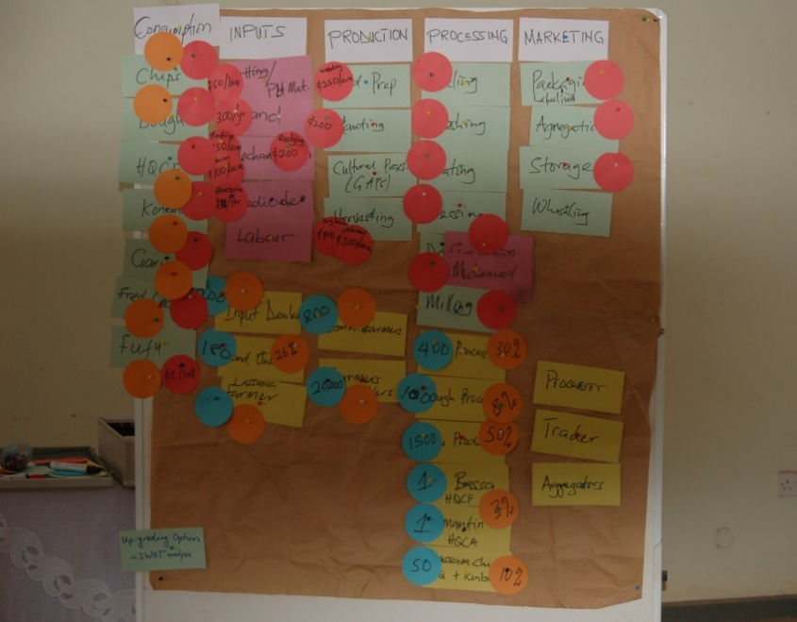

Figure 1: Result of mapping exercise of cassava value chain,
Sunyani May 2016

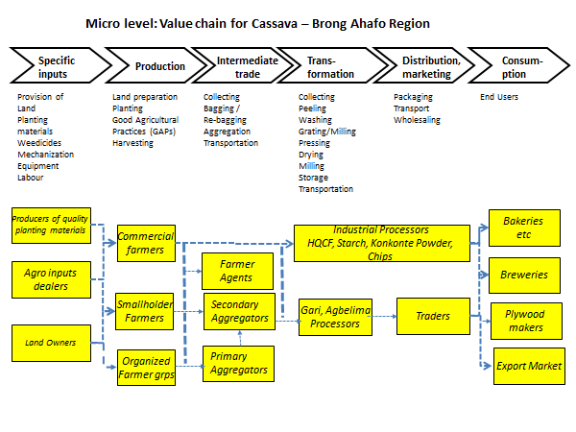
Figure 2: Stages, actors, and activities in the cassava value chain in Brong Ahafo
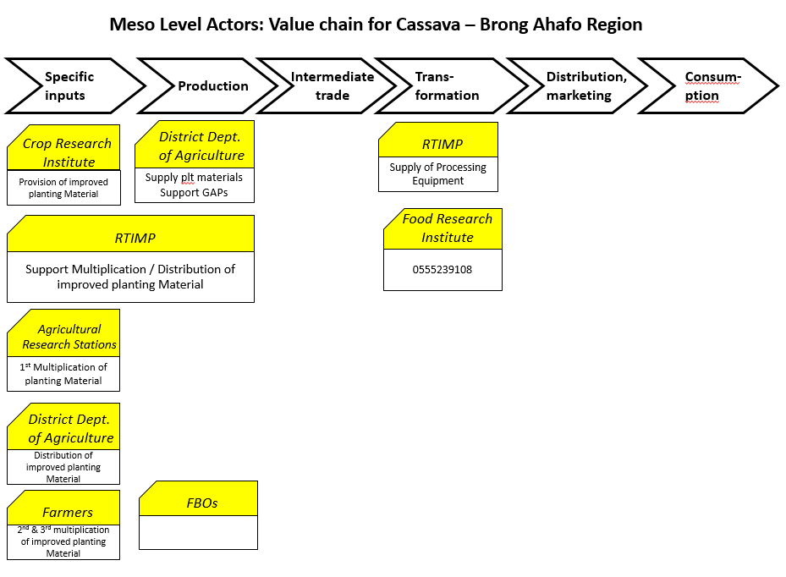
Figure 3: Organisations involved in the cassava value chain in Brong Ahafo

SWOT analysis of key products

The following section highlights the key strengths, weaknesses, opportunities, and threats for a selection of cassava based products in Ghana, namely fresh cassava roots, gari, HQCF, starch and ethanol. The results of the SWOT analysis have been summarised in Tables 1 to 5.

Table 1: Fresh cassava root production – SWOT analysis
Strengths | Weaknesses
- Cassava is a well-established crop known to farmers, traders, and end-users.  - Cassava tends to grow under difficult conditions, and plays an important role in the country’s food security system.  - Numerous projects are supporting the cassava value chain.  - New, high-yielding, cultivars have been developed and are being multiplied. | - Small-holder revenues are low when traditional cassava production takes place, and all labour inputs are costed.  - Lack of capacity to adopt good agricultural practices (  - Cassava is a food security crop, making industrialisation more difficult.  - The exact land sizes are often not known making estimation of yields and production difficult.  - Handling of planting material.  - Inadequate supply of improved planting material.  - Absence of unit measure of land and outputs.
Opportunities | Threats
- New markets for cassava roots are opening up in the industrial sector (e.g. it can be used as a raw material for starch, HQCF, ethanol, and animal feed production).  - Mechanisation, the use of improved varieties, and application of good agricultural practices is resulting in higher yields.  - Multiplication of improved planting material provides an income earning opportunity for farmers  - Supply models involving out-grower schemes can shorten the link between producers and processing industries, and provide livelihoods for small-scale farmers.  - Existence of research and other institutions that support production. | - Major cassava disease outbreak and lack of resistance of cultivars.  - Bush fires and long dry spells affect production.  - Large-scale production may reduce access to production resources by smallholder farmers, specifically land and labour where there are weaker relationships. Intensification of cassava production is likely to lead to labour shortages, and the increased use of mechanisation, including the use of herbicides for weeding (leading in turn to new environmental problems).  - Traders may be the main beneficiaries of efficiency gains from smallholder production if large quantities of roots need to be aggregated.  - Inadequate funding for research for continuous improvements in cassava technologies.  - Competition between cassava and other crops for land and other productive resources.

Table 2: Gari processing – SWOT analysis
Strengths | Weaknesses
- High national and international demand .  - Convenience food requiring little preparation once it has been processed into roasted granules.  - The product is well-established and does not require new introduction to processors or consumers alike.  - Gari production at SME-scale does not require a large capital outlay.  - Processors are well organised into groups and associations.  - Gari processors or their groups have strong market linkages with traders. | - Inadequate and inconsistent supply of fresh cassava roots.  - High cost of fresh cassava roots when supply is low.  - Use of local processing equipment is associated with low quantities of output, low quality, drudgery, and exposure to smoke.
Opportunities | Threats
- Availability of improved processing equipment can lead to higher throughputs and efficiency gains and improve health of processors.  - There is high-end market for quality gari (e.g. for middle-class consumers, or export markets).  - Market is increasing due to consumer preferences, purchasing power, and population growth.  - By-products such as peels can be used for animal feed, bio-gas production, mushroom production, and composting. | - Large-scale mechanisation of gari production (e.g. through factory-type plants) may make it difficult for SME producers to compete in terms of prices, and raw material supply arrangements.  - Disposal of effluents and cassava peels, and the use of firewood pose environmental risks.

Table 3: HQCF processing – SWOT analysis
Strengths | Weaknesses
- HQCF has received a lot of publicity and support (new improved technologies) during the last decade through various projects (e.g. C:AVA, RTIMP).  - The product has been tested and accepted by the market (e.g. in cake, biscuit, beer making, and animal feed production, and glue preparation in plywood and paperboard industries). | - The price of HQCF tends to be too high for some potential end-users (e.g. wheat millers).  - Sun-drying is difficult during the rainy season.  - Inconsistency of supply (e.g. quantities, quality) leads to some end-users losing their interest in buying HQCF.  - Low acceptance of HQCF as a component of flour for confectionaries due to inadequate sensitization of consumers.  - The turn-around and processing time is short and labour intensive.  - Additional investment is required for HQCF production.
Opportunities | Threats
- There is growing demand for products which can use HQCF as a raw material (e.g. beer production, cake and biscuit industry, paperboard and plywood industry).  - Technological progress has led to more efficient processing equipment (e.g. mechanised dryers) leading to better conversion rates and lower production costs.  - HQCF fetches a higher price than other cassava products (konkonte).  - Unexplored markets for companies that produce composite flours that use HQCF.  - Processing equipment can be locally manufactured (e.g. bin-dryers) or imported from within the sub-region (e.g. flash-dryers). | - Shortage of raw material in the form of fresh cassava roots.  - Increasing prices of fuel needed for mechanised drying (e.g. diesel or gas).  - Poor road network making transport of roots to processing sites within the turn-around time difficult.  - Lack of regulatory framework for HQCF production (it is understood that a framework has been developed but not yet published).

Table 4: Starch and ethanol production – SWOT analysis
Strengths | Weaknesses
- Investments have been made in starch and ethanol production, resulting in new factories using cassava roots as raw material.  - Technology can be imported if needed (e.g. from China, provided entrepreneurs have good links with suppliers of equipment).  - Starch and ethanol have many end-uses. | - Inadequate and inconsistent supply of raw materials.  - Some companies struggled with liquidity (e.g. shortage of working capital).  - Effluent control can be costly.
Opportunities | Threats
- There is growing demand for products using cassava based starch or ethanol as raw material.  - There are various initiatives supporting the cassava processing sector (e.g. GASIP, RTIMP, WAAPP, C:AVA).  - Availability of high-starch-yielding cassava varieties.  - Availability of institutions such as Government extension and NGOs to provide assistance in organising farmer groups and out-grower schemes.  - By-products from cassava processing can be sold for extra income | - High capital outlay may be required for certain imported technologies.  - Lack of regulatory framework for starch and ethanol production.

Governance of the Cassava Value Chain

Drivers of the value chain are considered to play a lead role in terms of value chain development and up-grading (e.g. innovations, linkages, quality assurance, etc). Traders have a strong governance role to play in the current value chain in that they provide the intermediary link between producers and consumers (e.g. as market queens). As such they convey market signals and ensure that supply meets demand. In particular, large traders (e.g. wholesalers) have a governance function in this respect.

Another group which has a cassava value chain governance function is the Government sector with its various services (e.g. research and extension) and projects (e.g. GASIP). It provides stimuli in the sector, amongst other things in the form of improved technologies, planting material and policy support.

Medium to large-scale processors (e.g. Gari. HQCF, starch, ethanol) represent a relatively new group in the value chain, playing a governance role. Given their links with the markets and to input suppliers (public or private sectors) they are in a position to influence both production of cassava roots and marketing of cassava based products. As such they play an important role as innovators in the sector, and their importance is likely to grow over the years to come.

Options for upgrading the value chain

Table 5 shows the upgrading options in the cassava value chain considered in this exercise. Other options have been considered (e.g. access to business development services, however not been taken into account for this exercise).

Table 5: Options for upgrading the cassava value chain
Fresh cassava root production | Processing | Trading
- Use of improved planting material, which is more disease resistant, higher yielding, and, where required, more geared towards industrial use.  - Application of good agricultural practices, leading to higher yields.  - Mechanisation of production, allowing larger areas of land to be cultivated and increase productivity  - Technical and managerial support to smallholder farmer groups to increase productivity. | - High-quality cassava flour (HQCF).  - Establishment of larger-scale, more commercial, gari processing factories.  - Continued use of existing factories (e.g. Ayensu starch factory).  - Establishment of new, large-scale factories (e.g. starch and ethanol plants).  - Increased production of industrial quality cassava chips or grits (e.g. for animal feed mixing or exports).  - Increased use of industrial quality cassava flour (e.g. for use in the plywood industry).  - Alternative transformation and marketing of by-products. | - Reduction of losses.  - Appropriate means of handling and transport  - Use appropriate means of storage  - Packaging of cassava products to make them more attractive to consumers.  - Promotion of cassava products (e.g. food fairs).
Standardisation of the value chain (e.g. use of contracts, standards, unit measurements)

A spreadsheet model has been prepared and used for the calculation of key indicators within each of these three areas where upgrading of the cassava value chain can take place. As for processing it ought to be noted that the emphasis was on gari processing, given that this type of processing was the most prevalent type of cassava processing enterprise encountered in Brong Ahafo during the time of the survey (May/June 2016). The team was aware of the existence of other forms of processing (e.g. fufu, HQCF, konkonte), however no related data has been gathered for several reasons (e.g. no HQCF was processed in May/June 2016 in Brong Ahafo due to high fresh root prices; it was agreed that the pilot model should be tested in the first place and once it was complete then the entire value chain should be taken into account for Brong Ahafo as well as other parts of the country).

Selected Results of the Value Addition Calculations

This section presents a selection of results generated by the pilot model regarding the value addition within the cassava value chain, with emphasis on cassava production, gari processing, and wholesale trading of fresh roots.

A number of steps have been followed to undertake data collection and analysis, namely:
- Preparation of checklists (see Appendix 2);
- Preparation of terms of reference jointly with the GASIP team (see elements of this above in Introduction)
- Meetings at the GASIP offices to agree on region to be covered;
- Meetings with various stakeholders within the cassava value chain (e.g. Government offices, farmers, processing groups, traders, NGOs, private sector input suppliers);
- Mapping of the value chain;
- Meetings to discuss findings and agree on data to be used for analysis;
- Analysis of findings;
- Completion of pilot model to calculate value addition with cassava value chain upgrades (Appendix 4).
- Sensitivity analysis to assess the impact on the cassava value chain of a 20% reduction of all output prices (i.e. of fresh cassava root farm-gate and wholesale prices, and gari prices).

The map of the cassava value chain is shown, demonstrating its various components. The findings of the value addition calculations are best summarised in the following Figure 5 and Table 6 showing results for individual enterprises (now and with achievable upgrades). It should be noted that prices considered were based on the situation in May/June 2016, when cassava root prices were high due to a shortage of supply. Detailed results can be found in Appendix 4.

Key findings

The importance of the cassava value chain for the entire Region is significant. For example, total value addition within the cassava value chain (production of fresh roots, processing of gari, and wholesale trading of 25% of the fresh roots) is estimated at about GhC 2 billion (at prices encountered in May 2016). This includes GhC 145 million in the form of imported intermediate goods and services (e.g. fuel or equipment), and GhC 30 million for remaining local IGS (e.g. input supplies).

The main components of value addition are labour and profit. For example, at production level (of cassava roots), it is estimated that labour income within the branch of the value chain covering small-scale farm production is GhC 948 million, compared to a total smallholder cassava production value which is GhC 1157 million. However, if the labour inputs were costed at the prevailing wage rate (GhC 15/day for an average work load) then the profits would be negative for smallholders. This means that farmers employing hired labour for cassava root production would face a negative gross margin (i.e. losses), whilst smallholders using predominantly family labour would do their work based on a daily wage rate (i.e. opportunity cost of labour) which is below the rate on the labour market (i.e. at about GhC 12 - 13 per day instead of GhC 15 per day). It should be mentioned that the labour inputs indicated by farmers during the field survey were quite high. To some extent this was due to inter-cropping practiced in the fields, and some of the labour inputs required for the second crop (e.g. maize or yams) have been allocated to cassava.

In terms of small-scale farmers producing cassava on one acre of land, this would mean that the value of production (i.e. GhC 1920) has to be compared to IGS (mainly transport of fresh roots) valued at GhC 735 and value addition of GhC1390 (i.e. GhC 1290 for hired labour or opportunity cost of family labour, plus GhC 100/acre regarding the value of land), leaving them with a negative profit margin of GhC -205/acre. The revenue is based on a yield of 8 tonnes per acre and the value of cassava roots is based on GhC240/tonne (i.e. sales price of roots, or cassava consumed by the family at home). If the IGS is broken down into its components (e.g. transport of roots broken down into means of transport, fuel, and labour), then the overall profit margin within the smallholder production part of the value chain would be close to zero (i.e. GhC –1.35/acre). This takes into account the profit of farmers, transporters, agro-input dealers, and other actors in the production part of the value chain.

Assuming a yield increase from 8 tonnes/acre to 12 tonnes/acre at smallholder level would lead to a value of production of GhC2880 per acre, and a positive profit margin of GhC 112 per acre (mainly due to higher output but also higher costs for harvesting and aggregation). If the calculation includes a break-down of intermediate goods and services (IGS) then the profit margin becomes GhC 388 per acre, leading to an overall profit margin for the entire region of the order of GhC 234 million.

Commercial farms have a higher profitability (i.e. estimated at GhC 974/acre) due to more efficient production methods, however their overall contribution to cassava production is rather limited (i.e. estimated at GhC 114 million for the region assuming that new production sites in districts such as Atebubu-Amantin have come into production). A productivity increase from 15 tonnes/acre to 20 tonnes/acre would result in a higher profit margin (GhC 1687/acre) and a total output worth GhC 152 million for the region. Commercial farms and large-scale agricultural production schemes should consider contract farming and the inclusion of smallholder outgrowers in the schemes. Amongst other things, this would allow to ensure that the smallholders use quality inputs and that they utilize them in the appropriate way.

Gari processing is a lucrative business which shows in the field (almost every village has a gari processing association) and in the calculations. Whilst a single small-scale gari processing operation (a grater, one or two presses, and about half a dozen frying stoves shared by a group of women) can generate a total output of GhC 280,000 per annum (2 tonnes per week, or 100 tonnes p.a. valued at GhC 2800 each), GhC 118,898 of this is profit, GhC 39,615 goes to labour inputs, and GhC 114,300 to raw material (i.e. fresh roots). The remainder goes into relatively small amounts of imported or local IGS, financial charges, or taxes and duties to be paid by the enterprises. Several cases have been seen where a processing facility belongs to one individual who hires out his equipment (e.g. grater, press, and frying stoves). Processors keep their profit margin once all the production inputs (e.g. fresh roots) or hiring charges have been paid for (e.g. for grater, press, or frying stove). Assuming that 30% of the region’s cassava production is processed into gari, and assuming a weekly output per facility of 2 tonnes of gari, would mean that 2920 of such gari processing operations exist in Brong Ahafo.

Medium-scale facilities have a larger throughput (e.g. 3.5 tonnes of output per week, or 175 tonnes per annum), more infrastructure (e.g. solid buildings), and a professional management. It is estimated that such an enterprise currently can generate a net profit of GhC 1904 per week. Taking into account a break-down of intermediate goods and services, the total profit margin for such an enterprise would be GhC 112,412 per annum (including for inputs), or GhC 674,471 for the entire region. This assumes that only 6 of these medium-scale facilities are currently in operation and 10 in future. The fact that at present medium-scale gari processing enterprises have a slightly lower profit margin as compared to small-scale processors, is due to higher production costs (e.g. depreciation of buildings, or labour costs which may also be higher because of social considerations). An efficiency increase in terms of higher throughput and amount of fresh roots required per tonne of gari produced (i.e. improved conversion factor from 21% to 25%) would result in a higher annual profit margin (i.e. GhC 240,309) per enterprise.

Cassava trading has been analysed for wholesale traders, who are assumed to trade a quarter of the output of roots (after deduction of home consumption and localised processing into products such as gari), often into other parts of the country (e.g. Accra, or Kumasi). Assuming that one wholesale trader has a throughput of 6 tonnes of cassava roots per week (i.e. sales of 300 tonnes per annum) would mean that about 3680 wholesale traders are in operation in Brong Ahafo region. In particular, in market centres such as Techiman a large number of cassava wholesale traders can be encountered, who further employ transport services and labourers to handle their produce. The annual value addition for one cassava wholesale trading operation is estimated at GhC 35,189 profits (including those of transporters), GhC 14,131 for labour, GhC 1,838 for financial charges and GhC 8,430 for taxes and duties. This is based on sales of GhC of 144,000 p.a., requiring raw material (i.e. roots) worth GhC 75,600, imported IGS worth GhC 6,638 (e.g. part of transport), plus other IGS worth GhC 2,175 p.a. This leads to regional figures of cassava wholesale sales of GhC 530 million, GhC 52 million for labour inputs, and GhC 129 million for profit margins. The latter would also account for the traders’ time spent in undertaking their business. It has been assumed that at present wholesale traders incur a physical loss of cassava roots of 5%. A reduction of the loss figures to zero would mean increased sales and profit margins for the wholesale traders (GhC 556 million and GhC 156 million respectively, for the region), assuming the costs would remain the same.

The overall results show that substantial gains in value addition can be achieved if the efficiency within the value chain can be improved (e.g. higher yields as a result of improved planting material and good agricultural practices; improvement of conversion ratio in gari processing from 21% to 25%; and reduction of losses in the trade of fresh cassava roots from 5% to 0%). As a consequence, the total value of the cassava value chain in the region would go up from about GhC 2 billion, to GhC 2.84 billion, including value addition and intermediate goods and services.

These figures must be seen in comparison with the fact that about 68% of households in Brong Ahafo region (i.e. 336,097, according to 2010 PHC) are agricultural households, and the majority of them cultivate cassava. Total cassava production was estimated at 4,637,229 tonnes produced on 256,827 hectares (estimated 2016).

A sensitivity analysis based on a 20% reduction of all output prices (given that the cassava root and gari prices were relatively high in May/June 2016) shows that cassava would still play an important role in the economy of Brong Ahafo, in that the cassava value chain would be worth GhC 1.6 billion and it is possible that this would go up to GhC 2.27 billion if the aforementioned value chain upgrading measures were implemented. At the same time, in the current situation the profit margin would be significantly more negative (GhC – 232 million) in the smallholder production part of the cassava value chain. An individual small-scale farmer producing on one acre of land would incur a loss of GhC - 589 per acre, if all the labour inputs were to be paid (GhC1290). This means that smallholders would have to put a much lower value on their labour rate (i.e. about GhC 8 per day) compared to the rate on the labour market (i.e. about GhC 15 per day). Profit margins would still be positive for gari processors and cassava root traders, albeit at a lower level. This would lead to a positive overall profit margin in the Brong Ahafo cassava value chain of GhC 114 million in the current situation, and GhC 407 million if the upgrading measures were to be implemented.

Performance of the value chain

Factor Cost Ratios (FCR) have been calculated in order to calculate the performance of the value chain. This performance indicator has been used, given that at this stage calculations have only been undertaken at market prices and not at shadow prices. The cassava value chain can be considered as efficient in that the output minus tradable (i.e. imported) inputs is greater than the cost of domestic resource factors (i.e. land, labour, and financial resources). The FCR is 0.68 for the current situation, and an FCR of 0.60 is achievable if the aforementioned value chain upgrades are implemented (the values are 0.86 and 0.76 respectively if output prices have been reduced by 20%). Other efficiency or performance indicators (e.g. Domestic Resource Coefficient) can be calculated if some of the calculations are made with shadow prices or opportunity costs (e.g. for labour inputs).

Social and environmental impacts of value chain upgrading

The aforementioned analysis has not covered in detail social impacts and sustainability of the cassava value chain, in terms of, working conditions, land and water rights, gender and social inclusion, food and nutrition security, social capital, infrastructure - health, housing, education and training.

Also, no analysis of environmental impacts was undertaken, which includes assessment of resource use (e.g. water, fuel, fertiliser, pesticides), emissions (e.g. CO₂, NH₃), and impact (climate change, eco-toxicity, toxicity, eutrophication, acidification, freshwater deprivation).

In view of this, it appears advisable that GASIP should consider to include team members in study missions who can cover these aspects of the value chain.

Figure 5: Value Addition Created by the Cassava Value Chain in Brong Ahafo
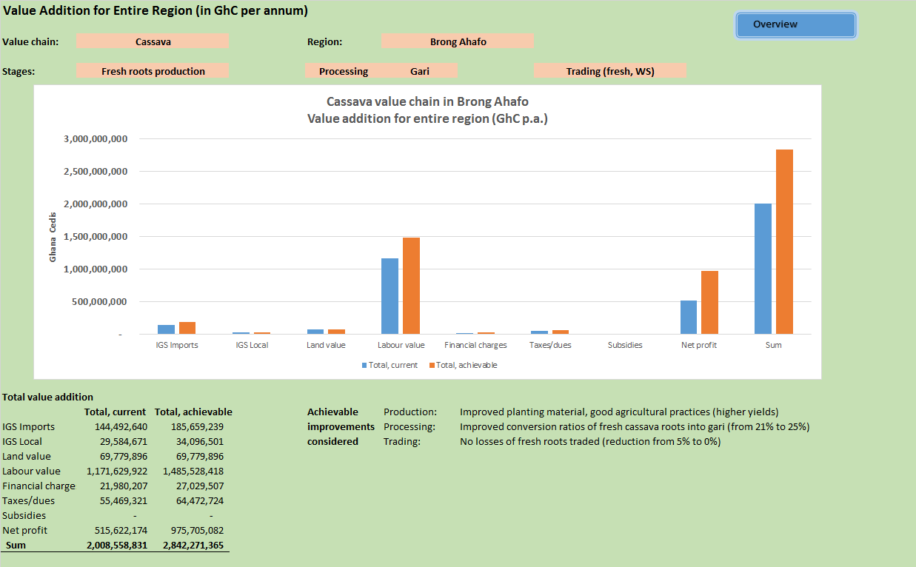

Table 6: Value Addition created by Stage in the Cassava Value Chain in Brong Ahafo
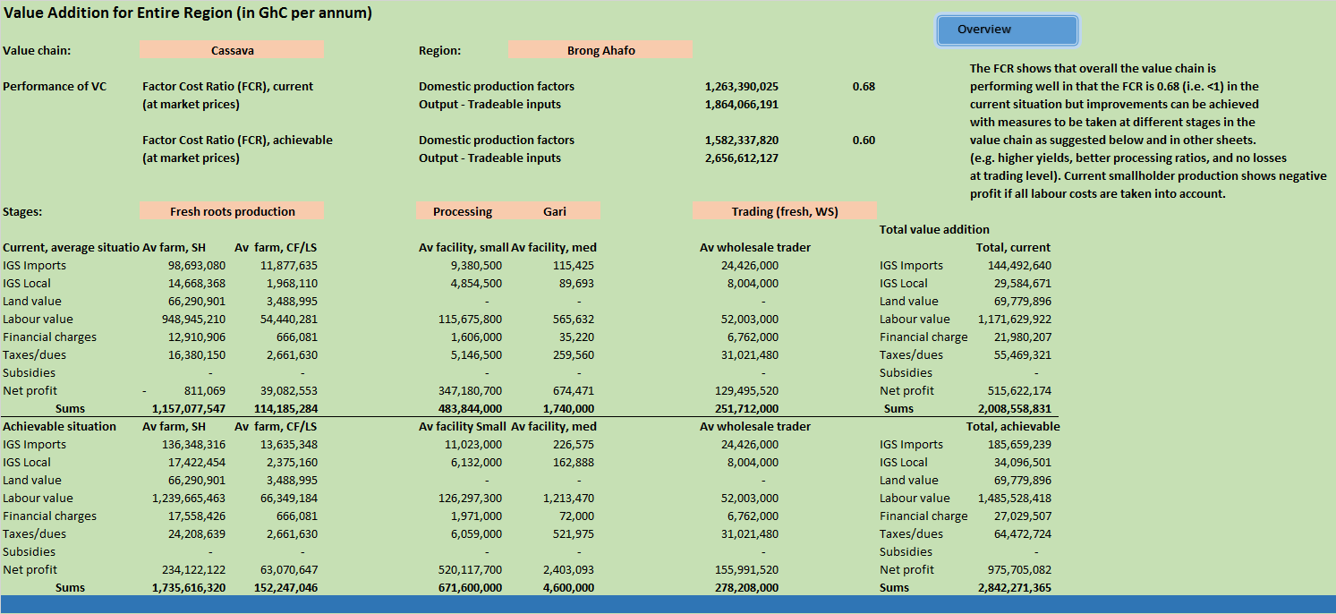

Appendices

Appendix 1: References

Bellù, L.G. (2013) Value Chain Analysis for Policy Making – Methodological Guidelines and Country Cases for a Quantitative Approach, EASYPol Series 129, Food and Agriculture Organization of the United Nations.

Bockel, L. and Tallac (2005) Commodity Chain Analysis – Financial Analysis, EASYPol Module 044, Food and Agriculture Organization of the United Nations.

Coulibaly, O., Arinloye, A.D., Faye, M., and Abdoulaye, T. (2014), Regional Cassava Value Chain Analysis in West Africa – Case Study of Ghana; International Institute of Tropical Agriculture (IITA) and West and Central African Council for Agricultural Research and Development (CORAF/WECARD).
a2015) The Operational Guide for
Fabre, P. (1996) Manuel analyse financière et économique des projets de développement ; Bruxelles: Commission européenne, 410 p.

Fabre, P., (1994) Note de méthodologie générale sur l'analyse de filière; Document de formation pour la planification agricole n° 35, FAO, Rome.

GIZ (2013) Contract farming handbook - A practical guide for linking small-scale producers and buyers through business model innovation; Eschborn.

GTZ (2007) Value Links Manual – The Methodology of Value Chain Promotion, Eschborn.

Humphrey, J. (2005) Shaping Value Chains for Development – Global Value Chains in Agribusiness; GTZ Trade Programme; Eschborn, Germany.

Kaplinsky, R. and Morris, M. (2002) A Handbook for Value Chain Research;
Prepared for the IDRC.

Kleih, U., Phillips, D., Tandoh-Wordey, M., Komlaga, G. (2013) Cassava Market and Value Chain Analysis - Ghana Case Study; Report for Cassava: Adding Value for Africa (C:AVA) project; Natural Resources Institute and Food Research Institute.

The Regional Director, Brong Ahafo Region (April 2016) Review Meeting Presentation, Kumasi, Ministry of Food and Agriculture.
Regional Analytical Report: Brong Ahafo Region. Ghana Statistical Service, June, 2013

2010 Population and Housing Census, Regional Analytical Report: Brong Ahafo Region. Ghana Statistical Service, June, 2013.
Raikes, P., Friis Jensen, M., and Ponte, S., (no date) Global Commodity Chain Analysis and the French Filière Approach: Comparison and Critique (forthcoming in Economy and Society).

Appendix 2: Checklists for fieldwork

MOFA / GASIP / IPCI / IFAD

Cassava Value Chain in Brong Ahafo, Ghana

Data requirements - economics

Overview of cassava production and value chain in the area

- Government services (agricultural development, statistics, extension)

- Input suppliers

- Farmers

- Processors

- Traders / marketing system

- End-users

- Support services
  - Business development services
  - Banks
  - NGOs
  - Others

Data collection methods

A range of data collection methods will be employed to collect data for the cassava value chain analysis in Brong Ahafo. The methods will not include a statistical survey but otherwise a mix of qualitative and quantitative methods. In particular, the following will be employed:

Government level – Accra and Kumasi
- Semi-structured interviews with Government officials
- Collection of data from primary and secondary data sources. This may include statistics from the Ministry of Food and Agriculture, Food Research Institute, Crops Research Institute. Also, reviews of government papers, surveys, and consultancy reports will be undertaken.

Local Government – Sunyani
- Semi-structured interviews with Local Government officials.
- Collection of statistics at LG level (e.g. land use, yields, production, prices)
- Semi-structured interviews with key informants (e.g. NGO staff, religious leaders, leaders of associations)

Cassava producers
- Individual interviews with farmers
- Focus group discussions (e.g. with mixed farmer groups, or men / women only), using participatory methods
- Semi-structured interviews with key informants (e.g. extension staff or NGO workers)

Traders
- Semi-structured interviews with traders and leaders of associations – most likely rapid market appraisal methods will be used for this (due to shortage of time at trader level).
- It has to be seen to what extent focus group sessions (e.g. at trader association level) can be envisaged.

Processors
- Focus on cassava drying (e.g. bin-drying or sun-drying), plus possibly a few traditional processing enterprises (e.g. gari).

Potential investors
- Semi-structured interviews with key informants, including potential investors themselves

Support services (e.g. banks, micro-finance institutions, business development services, NGOs)
- Semi-structured interviews with key informants

Checklist for discussions with Government services
Name and location of service
Name and title of person interviewed
Date

Agricultural and cassava value chain - objectives
Policies
Activities (projects)
Staff
Geographical areas covered
Other organizations involved in agricultural / cassava VC

Agricultural and cassava value chain – documents
Documents (government policy, surveys, consultancy reports)
Statistics
Agricultural produce / cassava
Break-down of certain prices (e.g. imported fertilizer or fuel; in terms of CIF import costs, transport, labour, duties, etc)
Ask for access to statistics

Stakeholders involved in the cassava value chain
Agents
Activities in the value chain
Sub-value chains
If possible, ask if value chain can be drawn
Quantities / percentages in the VC
Prices of cassava products

Government support and income
Support for cassava value chain
Subsidies in terms of financial support or in kind (e.g. tax breaks, machinery, irrigation infrastructure)
Income from cassava value chain (e.g. trade taxes, export duties)

Discussion regarding cassava value chain
Use parts of questions in checklist of key informants
CKECK-LIST FOR DISCUSSIONS WITH INPUT DEALERS

[Explain background to the project, but ensure that this does not lead to biased answers]

General Information

What type of dealer (i.e. intermediary, wholesaler, or retailer)?

Gender of trader?
Where is s/he located?

Interview

Which agricultural inputs do you sell?

From whom do you buy and where?

At what price do you BUY? How is price determined?

What quantities do you buy and sell per week? Has your business declined or expanded in the last three years?

How do you transport your products?

What are your marketing costs (per unit)? What are transaction costs that are less “visible”

How do you pack and transport agricultural inputs? How much is lost after transport? Reasons?

Who are your customers, and where are they based?

At what price do you SELL? How is price influenced by varieties, seasonality, size and quality of produce / product?

How is price determined?

Do you do any sorting and grading?

What are your sources of market information? And how do you use it?

Do you get credit?

Is there an agricultural input dealer association? How does it function?

What are your problems? Please rank (verbally) ?

What are your suggestions?

Mapping of the value chain or parts of it can be done if the dealer has time and is knowledgeable.
Thank dealer for time and information given!

Checklist for interviews with KEY INFORMANTS

(Key informants include here stakeholders that are knowledgeable about the cassava value chain without necessarily participating in it. More detailed checklists are available below for farmers, traders, processors, end-users and other value chain participants)

Background of key informant

Name of the person and organisation s/he works for

Sector background (e.g. NGO, Gvt. Extension, private sector)

Knowledge of cassava value chain

Specific questions:

Overview of farming system

Local economic system;

Availability of land; land tenure system; soil quality

Crops grown (in general, and importance of cassava in the farming system);

Role of women in agricultural production, processing, and trading;

Organisation of farmers and processors (i.e. associations).

Cassava production in the region (are there statistics available?)

Varieties grown and their characteristics;

Types of processed cassava products produced in the region;

Technology used for cassava production and processing;

Role of women in cassava production and processing.

General constraints faced by producers and processors;

Cassava projects and other initiatives in the region; how well have they done?

Role of extension services (Government, NGOs, private sector players)

Cassava processing

What type of cassava processing does take place in the region?

Which processed products are prepared, quantities of cassava used, stakeholders involved, technologies used.

Cassava markets – main markets, actors, and prices?

Main markets: community markets, wholesale and retail markets – their location and size in terms of turn-over

Main actors involved: collectors, wholesalers, retailers

Processed cassava products (please specify using percentages as much as possible)

How much fresh or processed cassava goes into which channel (percentages)

Prices at different levels in the value chain

Functioning of the value chain – do mapping exercise
Therefore best to take along flip-chart paper and marker pens

Steps involved between production and consumption for different chains

Stakeholders involved

Role of women in the chain

Technical steps involved

Transactions involved, and associated costs

Governance of the value cain

Constraints faced by traders and intermediaries

Service providers active in the cassava value chain (e.g. Government services, NGOs, banks, business development services)

Role of linkage facilitators (e.g. private sector intermediaries; NGOs, BDS), suggestions on how linkages could be strengthened.

Sketch out “new” cassava value chain as compared to traditional one.

Conclusions

How well is Brong Ahafo suited to supply substantial quantities of cassava to the processing industry?

It is important that the region is a surplus supplier.

Ideas on how value chain could be built up / strengthened to the benefit of small-scale farmers and processors.

Lessons from past experience. Pitfalls that should be avoided.

CKECK-LIST FOR FARMER GROUP MEETINGS

[Explain background to the project, but ensure that this does not lead to biased answers]

General Information

Village: Name
District
Size/Inhabitants
Agro-climatic zone

Number of participants in group meeting (M/F):

What are the villagers' main economic activities?
Please rank in order of importance!

What were the main changes in the economic system within the last ten years?

Agricultural Production

Type of farming system and changes within past ten years?

What are the main crops planted in the last year, specifying season? please rank in order of importance!

Crop Area Quantity How much
planted Harvested sold

(It may be appropriate to speed up discussions on this question if farmers have difficulties to agree on numbers.)

What are the reasons for the main crops planted?

Varieties of cassava grown?

Extension

Have you ever received any extension education about cassava production?
From whom, what kind of information, how often?

Harvesting of Cassava

When?

Who in the household harvests cassava – men, women or children?

Harvesting techniques used?

Type and extent of loss due to harvest?

What are the constraints related to harvesting and what do farmers suggest?

Storage of Cassava

How is cassava stored? Technologies?

Who in the household is responsible for storage?

Where, when, and for how long is cassava stored?

Type and extent of loss occuring during storage?

What are the constraints related to storage and what do farmers suggest?

Processing of Cassava

Do you process cassava? If yes, into what products - please rank in order of importance?

Who is in charge of processing – women, men, or children?

Processing techniques and equipment? Who owns the equipment?

Quantities of raw material processed?

What are labour requirements? What are processing costs?

Quantities of processed products obtained?

Is processed cassava mainly for sale or home-consumption,
please specify?

How are products stored? How long, where, by whom?

How are products dried? For how long are the products dried?

Does loss occur during and after processing?

What are the amounts lost?

What are the main constraints in processing cassava? Please rank in order of importance?

What do you suggest to solve these problems?

Marketing of Fresh and Processed Cassava

How important is cassava for you as a cash crop – fresh or processed products?

Who is in charge of selling cassava, and who keeps the money from sales?

Please explain the marketing systems of fresh and processed cassava?

Who do you sell to, where, when, how much at what price, and why?

How do prices change within the year?

How did prices change compared to the last five years?

Do you listen to the price broadcast on the radio?
What's your information about other markets?

Do you grade the cassava before selling it?

How do differences in quality influence the price?

How does age of product influence the price?

Do you package cassava (fresh or processed) before selling it? At what cost?

How do you transport cassava to the point of selling, at what cost?

What are the main constraints in marketing cassava, please rank in order of importance and explain?

What kind of changes/improvements do you suggest?

Suggestions from farmers about improved marketing of cassava.

Discuss with farmers how a value chain for cassava should be organised so that they can obtain the maximum benefit.

CKECK-LIST FOR DISCUSSIONS WITH CASSAVA TRADERS

[Explain background to the project, but ensure that this does not lead to biased answers]

General Information

What type of trader (i.e. intermediary, wholesaler, or retailer)?

Gender of trader?
Where is s/he located in the market?

Interview

Which products do you trade?

From whom do you buy and where?

At what price do you BUY? How is price influenced by varieties, seasonality, size and quality of produce / product?

How much do you buy and sell per week? Has your business declined or expanded in the last three years?

How do you transport your products?

What are your marketing costs (per unit)? What are transaction costs that are less “visible”

How do you pack and transport cassava? How much is lost during transport? Reasons?

Who are your customers, and where are they based?

How is price determined?

At what price do you SELL? How is price influenced by varieties, seasonality, size and quality of produce / product?

Do you do any sorting and grading?

What are your sources of market information? And how do you use it?

Do you get credit?

How does the market association function?

What are your problems? Please rank (verbally) ?

What are your suggestions?

Mapping of the chain can be done if the trader has time and is knowledgeable.
Thank trader for time and information given!

CKECK-LIST FOR DISCUSSIONS WITH PROCESSORS

[Explain background to the project, but ensure that this does not lead to biased answers]

Introduction

Name of interviewee, provided s/he wants to give it?

Location of business (name of village, any specific characteristics)?

Type of business?

Gender of business owner?
Please explain the different processing steps in your business.

What changes have occurred in your business within the last five years?

Raw material

What is the source of raw material? What are the contractual arrangements with suppliers? How are prices and quantities set?

What varieties are used?

Quantities of raw material handled per week? Seasonal changes?

Maximum quantity of raw material you can process per day or per week (capacity)?

Quality of raw material (age)? How much time is spent between harvesting and processing?

Varieties used?

Do you grade raw material before processing and what happens to the various grades?

Prices paid for raw material? Seasonal changes?

Drying – time taken for drying?

Storage of raw material? How and how long?

Problems related to raw material? Please rank?

Processed Products

Which end-products are obtained?

Ratio of fresh to processed products?

Throughput per week? Volume of product obtained per week?

What are the processing constraints?

Do you grade your end-products? Criteria for grading?

Processing Costs

If processor is owner of equipment:

Labour requirements per processing activity (including your own and hired labour)? Gender of workers?

Expenditures for hired labour per day, week or year?

Fuel and lubricants costs per week?

Water costs per week?

Packaging costs?

Other operating costs?

Investment costs (building, machines, etc)?

How long can equipment and facilities be used?

Annual taxes and levies (if any)?

What do you charge for processing (if toll processing takes place)?

Other uses of facilities?

Problems with processing? Please rank?

If processor is not owner of equipment:

How much do you pay for processing (per bag, basket, or other unit)?

Labour requirements per activity (including your own and hired labour) ?

Expenditures for hired labour (if any)? Gender of hired labour?

Costs of transport to and from processing site?

Packaging costs?

Other operating costs?

Annual taxes and levies (if any)?

Problems with processing? Please rank?

Marketing of End-Products

Customers: Types of buyers, and gender
Where are they from?
What are their preferences (don't forget export)?

Contractual arrangements (cash or sale on credit)?

Quantities sold per week, month or year (seasonality) ?

Prices obtained (seasonality) ?

Where do you sell (seasonality) ?

Marketing costs (depending on season):
Transport
Tolls and fees
Handling charges
Other costs ?

Has your business declined or expanded during the last five years?

Do you have ready market for your produce? If you were able to produce more, could you sell it? If yes, why didn't you increase your production? Have you ever had requests in terms of quality and quantity from your customers which you could not meet? If yes, from whom, and why couldn't you fulfill these demands?

Problems with marketing? Please rank ?
By-products

Use of by-products ?

Income obtained ?

Association

If there is an association: how is it organised? How many members does it have (male and female)? etc.

Problems with association? Please rank?

Table 1a: Cassava production – costs and inputs (GhC per acre)

Location: ___________________ Date: __________ Interviewee: __________________ Time/season covered: _____

# | Operations  (first to last in season) | Labour requirements |  |  | Input requirements |  |  |  | Remarks
 |  | Person - days | Cost / day | Total  costs | Qty | Units | Cost/  unit | Total costs

Table 1b: Cassava production – costs and inputs (GhC per acre) - continued

Location: ___________________ Date: __________ Interviewee: __________________ Time/season covered: _____

# | Operations  (first to last in season) | Labour requirements |  |  | Input requirements |  |  |  | Remarks
 |  | Person - days | Cost / day | Total  costs | Qty | Units | Cost/  unit | Total costs

Table 2: List of investments – Cassava production
Type of investment | Investment costs (in GhC) | Useful life | Capital costs (interest rate and instalments) | Maintenance
Land
Buildings
Equipment (hoes/baskets/buckets ..)
Machines (e.g. tractor)
Irrigation infrastructure
Vehicle (e.g. pick-up truck)
Other

Table 3: List of investments – Cassava processing
Type of investment | Investment costs (in GhC) | Useful life | Capital costs (interest rate and instalments) | Maintenance
Land
Buildings
Machines 1
Machines 2
Water and sewerage infrastructure
Vehicle (e.g. pick-up truck)
Other

General data to be collected

Data related to value addition

- Interest charges (different data from commercial banks; agricultural development banks; micro-finance institutions)

- Taxes and duties (for different inputs and outputs of the Cassava value chain)

- Support by Government or other organisations (e.g. NGOs) in terms of financial subsidies, support in kind – this applies to agricultural producers, but also other stakeholders such as transporters, traders, etc

- Salaries: official minimum wages; wages for skilled and unskilled workers in Sunyani, and rural areas; salaries for managers

Cost of specific inputs:
- Transport charges, fuel costs (e.g. diesel and petrol), electricity, water, agricultural inputs (e.g. seeds, fertilisers, chemicals)

Break-down of traded inputs into their components
- (e.g. labour, taxes and tariffs, financial charges)

Exchange rates
- Official exchange rates for different currencies; shadow exchange rates as far as applicable

NB. This type of data will be collected at different levels.

Appendix 3: People and organisations met in Ghana

NAME | ENTITY | Designation/Category | Location
MEETING WITH AGRIBUSINESS UNIT OF MAOFA ON 16/05/2016
Mr. Nicholas Neequaye | Agribusiness Unit, MoFA | Director | Accra
MEETING WITH FOOD RESEARCH INSTITUTE, CSIR ON 17/05/2016.
- Gregory Komlaga | FRI, CSIR | Team leader, C:AVA | Accra
- Marian Tandoh Wordey | FRI, CSIR | Business Development Advisor, C:AVA Project | Accra
MEETING WITH PRIVATE SECTOR ACTORS
- William Adjei | Ghana Cassava Centre | Managing Director | Accra
- Chris Quarshie | CALTECH Ventures Limited | Managing Director | Accra
MEETING WITH STAFF OF REGIONAL DEPARTMENT OF AGRICULTURE, ASHANTI REGION
- Fordjuor | Department of Agriculture | Director | Kumasi
- Hajia Karima | Department of Agriculture | Accountant | Kumasi
- Edward Nasara | Department of Agriculture | RO-Extension | Kumasi
- Benjamin Nii Norm | Department of Agriculture | M&E Officer | Kumasi
- Ayiribi Danso | Department of Agriculture | WIAD | Kumasi
- Amo Korang | Department of Agriculture | RO-Crops | Kumasi
MEETING WITH PROVACA
- Joseph Yeboah | PROVACA | Coordinator | Ashanti Region
MEETING AT THE BRONG-AHAFO REGIONAL DEPARTMENT OF AGRICULTURE ON 19/05/2016
- Dr. Cyril T. Quist | Department of Agriculture | Director | Sunyani
- Ofosu Denkyira | RDA | RO-Crops | Sunyani
- Gilbert Sankpi | RDA | RO-Extension | Sunyani
- Bashiru Fuseini | RDA | GIZ-MOAP | Sunyani
ST. BAASA GHANA LIMITED
- Baah Dapaah | St. Baasa Ghana Limited | CEO | Chiraa, BAR
- Constance Frimpong | St. Baasa Ghana Limited | Director | Chiraa, BAR
- Stephen Adjei |  | Farmer | Chiraa, BAR
- Fusieni Shaibu |  | Farmer | Chiraa, BAR
- Afua Fuseini |  | Farmer | Nkoranza, BAR
- Atta Donyira |  | Farmer | Nkoranza, BAR
- Adomah Yeboah-Afari |  | Farmer | Koforidua Nsuta, BAR
MEETING WITH GARI PROCESSORS AT KOFORIDUA NSUTA PROCESSORS
- Adoma Yeboah | Nsuta Processing Centre | CEO | Koforidua Nsuta, BAR
- Ama Mary | Nsuta Processing Centre | Cassava Peeler | Koforidua Nsuta, BAR
- Donkor Janet | Nsuta Processing Centre | Cassava Peeler | Koforidua Nsuta, BAR
- Abena Damoah | Nsuta Processing Centre | Cassava Peeler | Koforidua Nsuta, BAR
- Abdul Karim | Nsuta Processing Centre | Mill-operator | Koforidua Nsuta, BAR
TWUMASIKROM , NSUATRE
- Afi Kumah | Resident | Gari processor | Twumasikrom, BAR
- Naomi Badu | Resident | Gari processor | Twumasikrom, BAR
- Vida Aggyeman | Resident | Gari processor | Twumasikrom, BAR
- Akosua Badu | Resident | Gari processor | Twumasikrom, BAR
- Comfort Gyewu | Resident | Cassava producer | Twumasikrom, BAR
- Kwesi Henyo | Resident | Cassava producer | Twumasikrom, BAR
- Godwin Amuzu | Resident | Cassava farmer | Twumasikrom, BAR
MEETING WITH AGGREGATORS AND TRANSPORTERS
- Yaa Sikayena |  | Trader | Sunyani Barrier
- Lydia Serwaa |  | Trader | Sunyani Barrier
- Hannah Boatemaa |  | Trader | Sunyani Barrier
- Serwaa Akoto |  | Trader | Sunyani Barrier
MEETING WITH HARII FARMS
Joshua Neensaw | Harii Farms Limited | Supervisor
BOMAA APESIKA PROCESSING CENTRE
- Abena Ajeiwaa | Resident | Gari processor | Bomaa Apesika
- Beatrice Mensah | Resident | Gari processor | Bomaa Apesika
- Ama Pokuyaa | Resident | Gari processor | Bomaa Apesika
- Asante Sampson | Resident | Mill Operator | Bomaa Apesika
- Frank Boateng | Resident | Mill Operator | Bomaa Apesika
- Samuel Mensah Abrampa | Cassava producers and processors Association | President | Bomaa Apesika
- Delali George | Resident | Cassava producer and gari processor
METHODIST UNIVERSITY
- Prof. D.K.W. Mensah | Methodist University | Dean of Faculty of Agriculture | Wenchi
WENCHI AGRICULTURAL RESEARCH STATION
- Macilinus Babai | Wenchi Agric. Station | Research Officer | Wenchi
- John Aja | Wenchi Agric. Station | Research Officer | Wenchi
- David Gyan | Wench Agric. Station | Research Officer | Wenchi
- Arthur Robert | Wenchi Agric. Station | Station Manager | Wenchi
- Rev. Daniel Osei Sarfo | Wenchi Agric. Station | Research Officer
AMPONSAKROM
- Fuseini Seidu | Adombi Apue Cassava Farmers and Processors Association | Cassava producer | Amponsakrom, Brong-Ahafo Region
- Stephen Danyi | Adombi Apue Cassava Farmers and Processors Association | Chairman | Amponsakrom, Brong-Ahafo Region
- Mariana Issah | Adombi Apue Cassava Farmers and Processors Association | Producer and Processor | Amponsakrom, Brong-Ahafo Region
- Mahamudu Alhassan | Adombi Apue Cassava Farmers and Processors Association | Producer | Amponsakrom, Brong-Ahafo Region
- Jalia Mahama | Adombi Apue Cassava Farmers and Processors Association | Producer | Amponsakrom, Brong-Ahafo Region
- Nana Achireku | Adombi Apue Cassava Farmers and Processors Association | Producer | Amponsakrom, Brong-Ahafo Region
- Abu Gyawu | Adombi Apue Cassava Farmers and Processors Association | Producer | Amponsakrom, Brong-Ahafo Region
ASOGYA AGRO PROCESSING CENTR
Mrs. Faustina Sekyi | Asogya Agro Processing centre | Managing Director | Asueyi, Techiman District, Brong-Ahafo District
KOKOFU, KWAME DANSO, ATEBUBU
 | Odokuo | Gari Processors | Kokofu, Atebubu.
TECHIMAN MARKET
 | Techiman Central Market | Cassava Trader | Techiman
AMADU FARMS
- Mahamadu Owusu Aduomih | Amadu Farms | C.E.O. | Atebubu Amanten District
- Wilfred Ananoga | DoA | Director | Atebubu Amanten District
- Edward Amissah | DOA | A.E.A. | Atebubu Amanten District
JOSMA AGRO PROCESSING INDUSTRY
- Janet Gyimah Kesseh | JOSMA Agro Processing Industry | C.E.O. | Mampong
- Nkrumah | JOSMA Agro Processing Industry | Farm Manager | Mampong
- Senya Amoah Emmanuel | JOSMA Agro Processing Industry | General Manager | Mampong
KANTURO COMMUNITY CASSAVA FARMERS
- Nana Amoako |  | Maize/Cassava Farmer | Kanturo
- Kwebena Takyi |  | Maize/Cassava Farmer | Kanturo
- Daniel P. Biebareri |  | Maize/Cassava Farmer | Kanturo
- Azubila Abanga |  | Maize/Cassava Farmer | Kanturo
- Gilbert Biimour |  | Maize/Cassava Farmer | Kanturo
- Vlabachine Diana |  | Maize/Cassava Farmer | Kanturo
VISIT TO NBSSI ON 30/05/2016
- Abdul Rahamana Talhart | NBSSI | Regional Accountant | Sunyani
- Ophelia Aponsah Tebi | NBSSI | Business Advisor | Banda District, Brong-Ahafo Region

Appendix 4: Components of Pilot Model to Calculate Value Addition of Cassava Value Chain in Brong Ahafo

Appendix 4

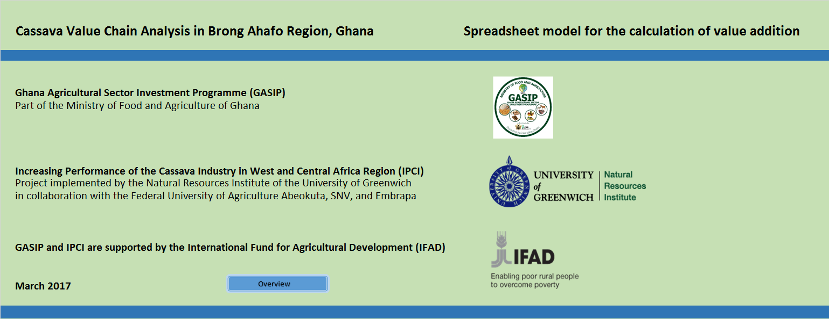

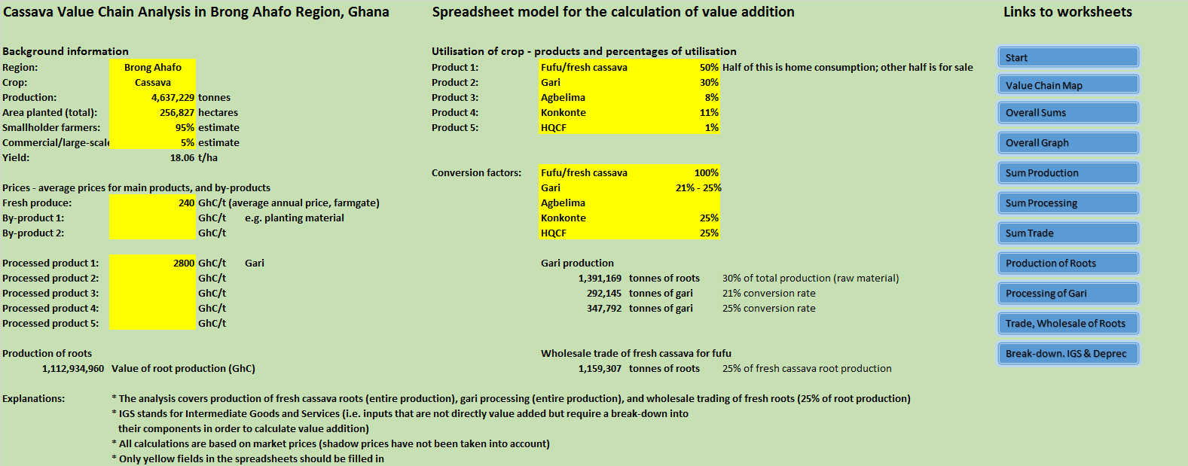

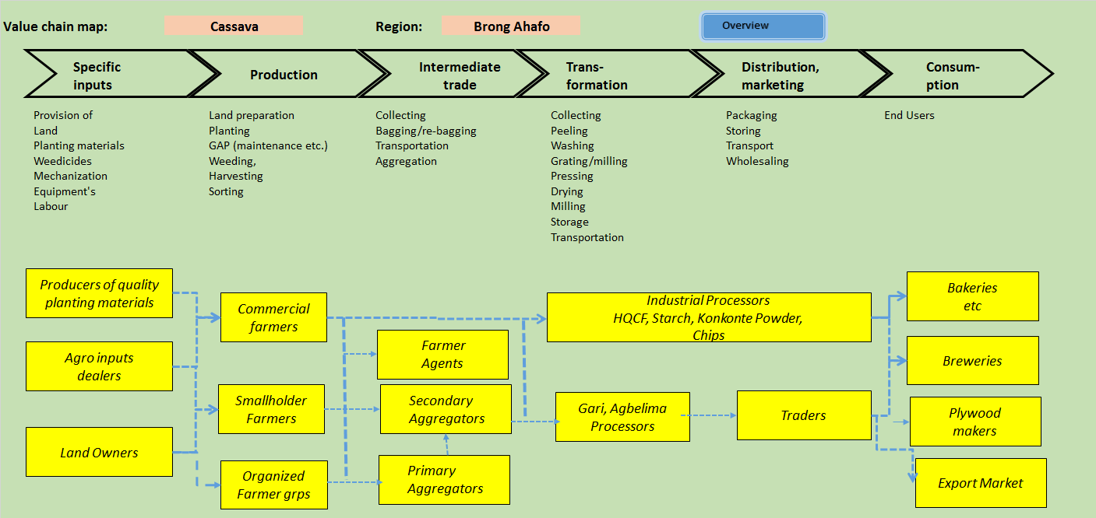
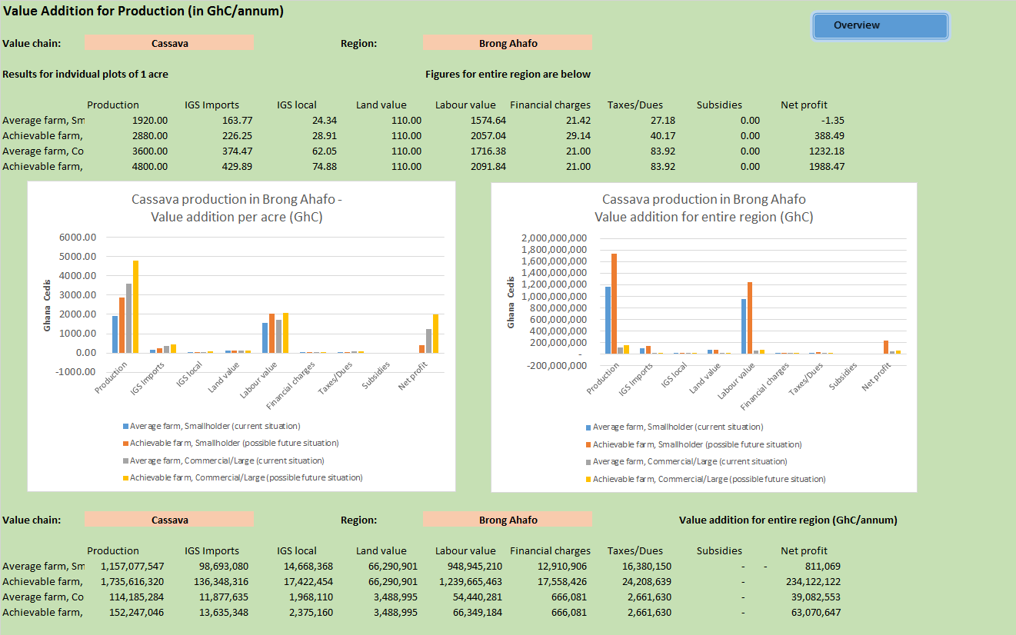
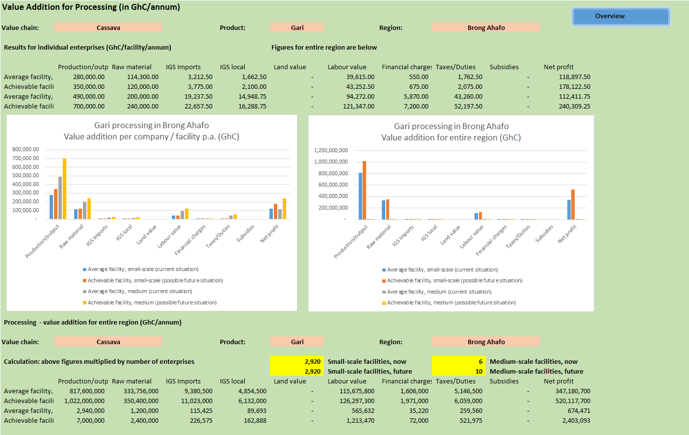
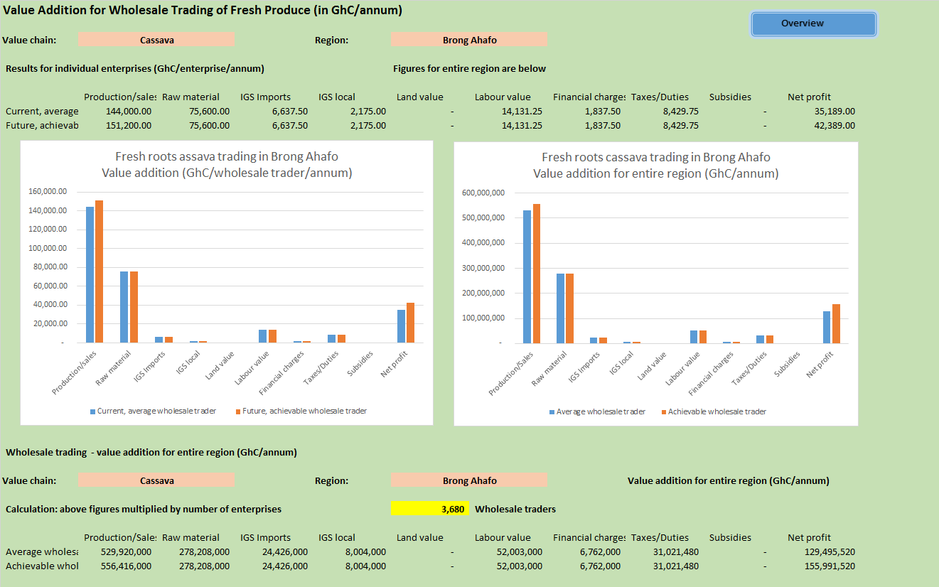
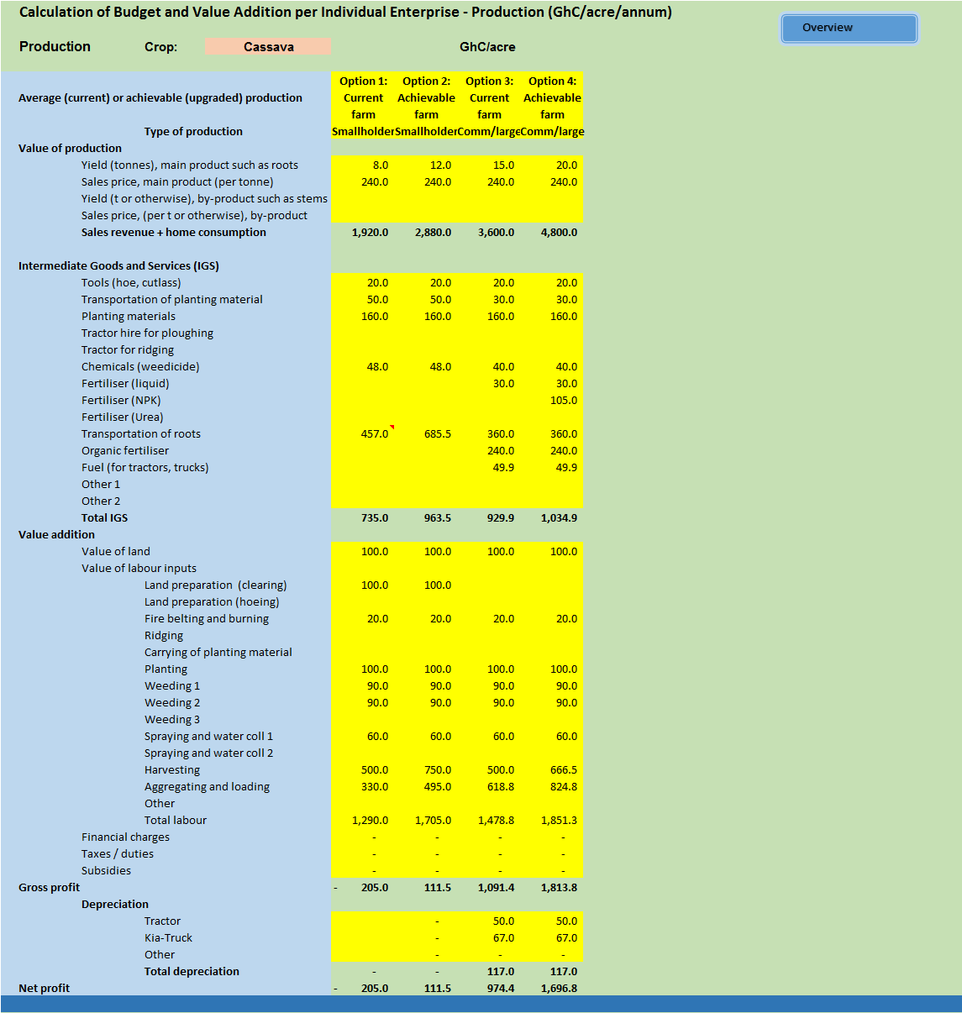
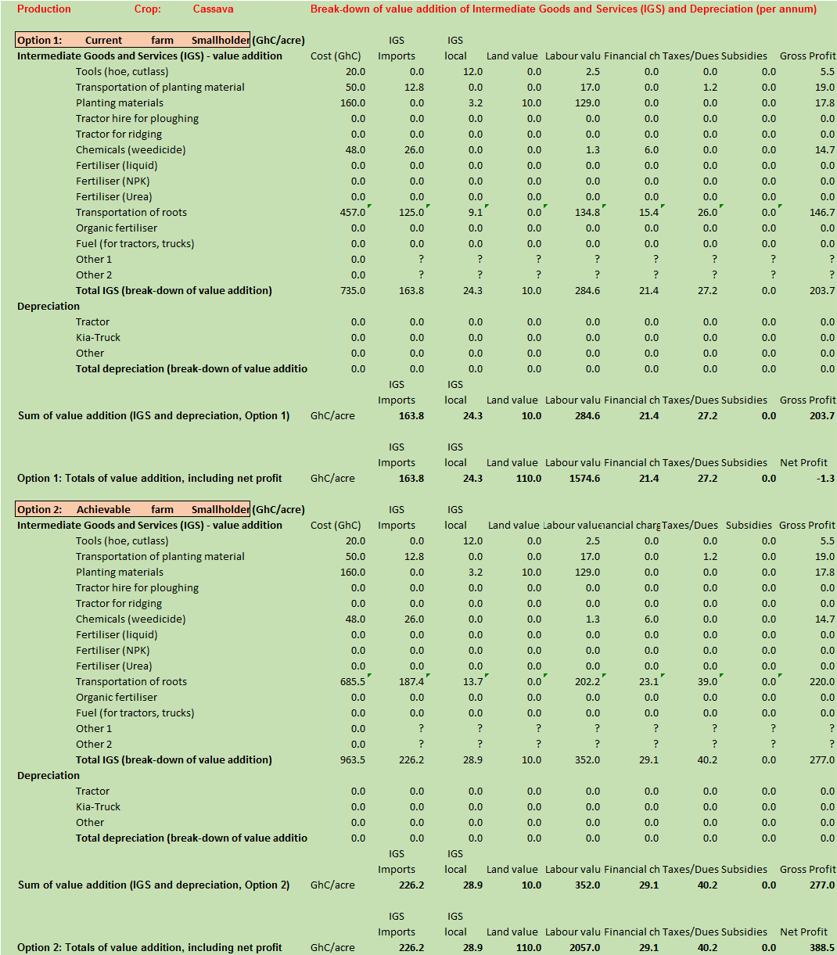
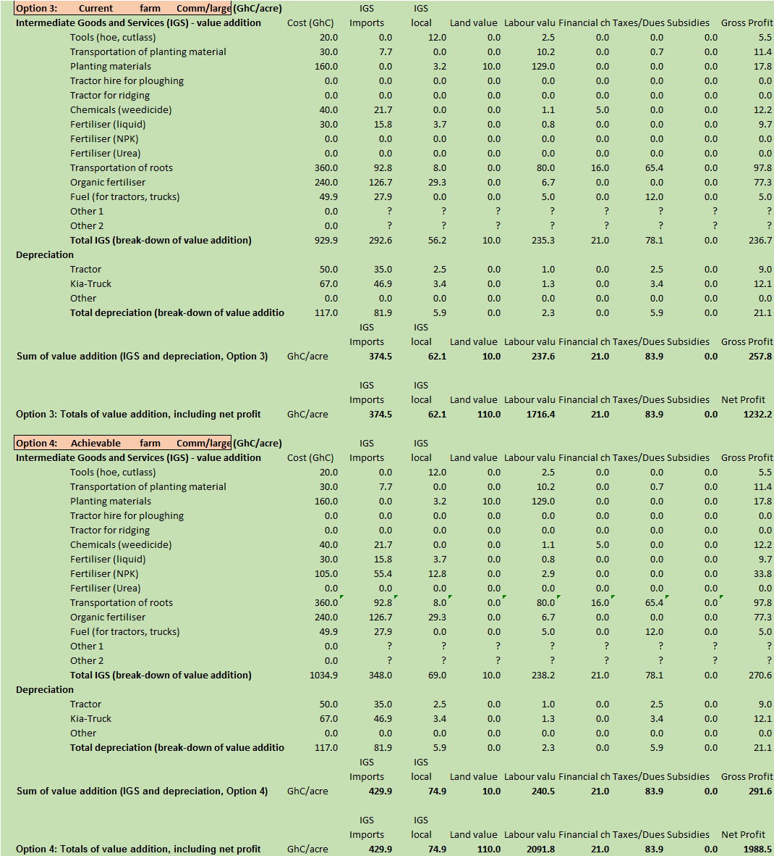
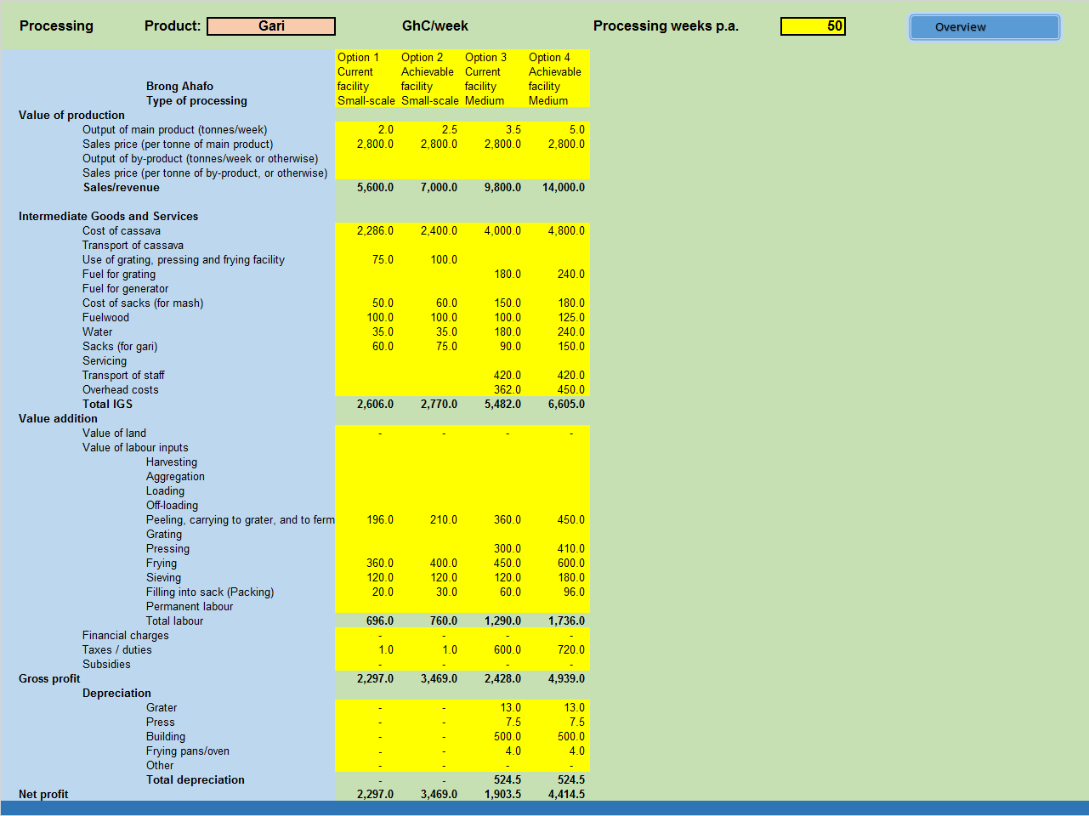
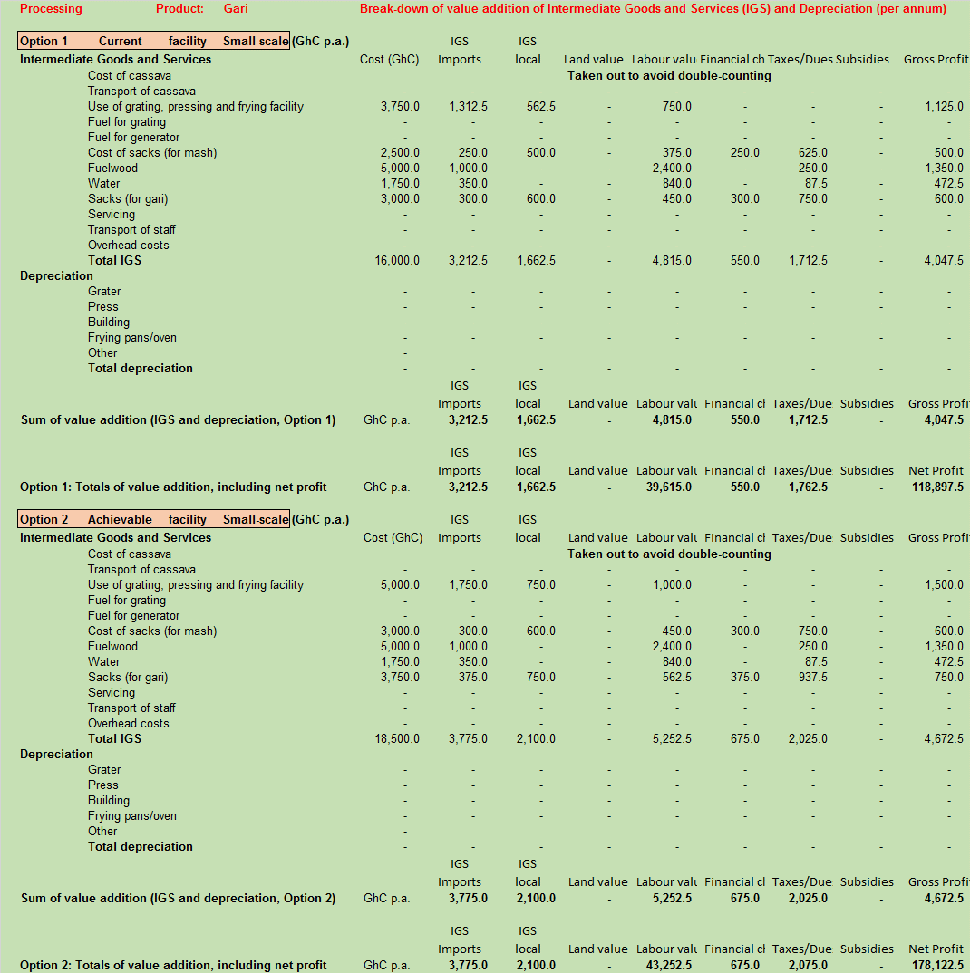
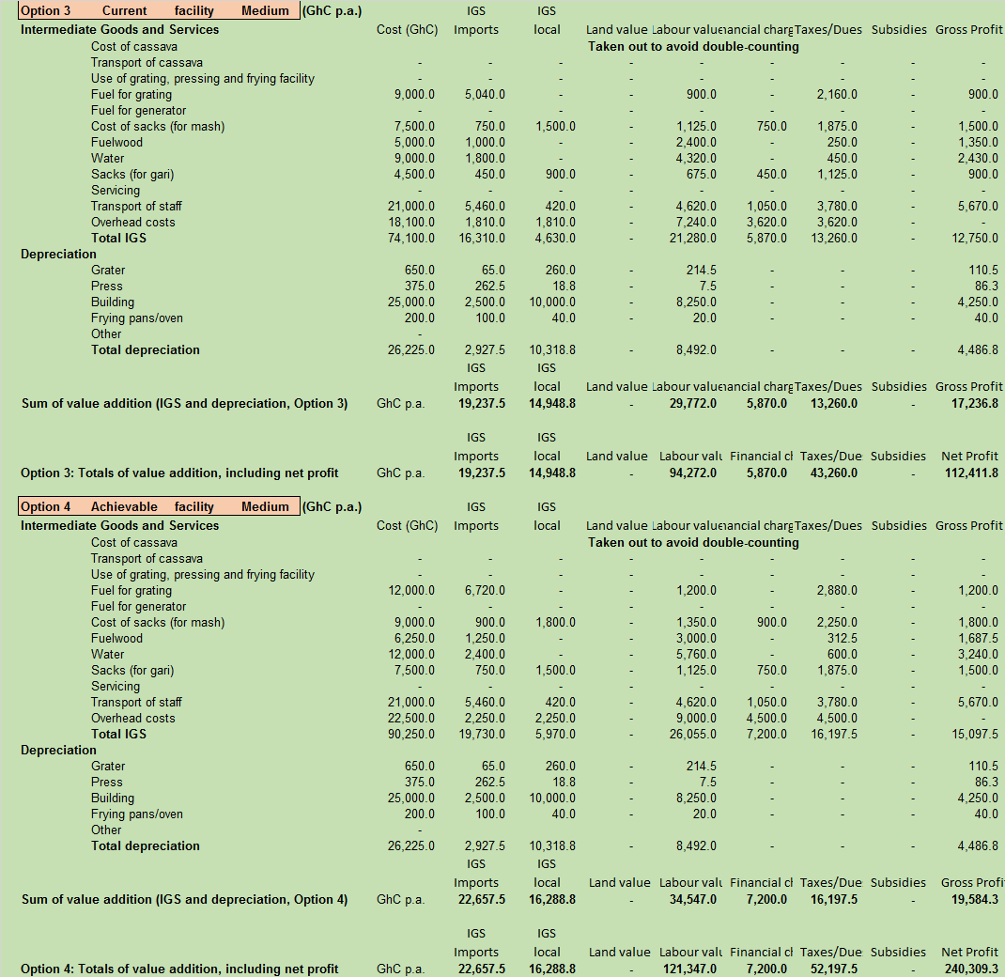
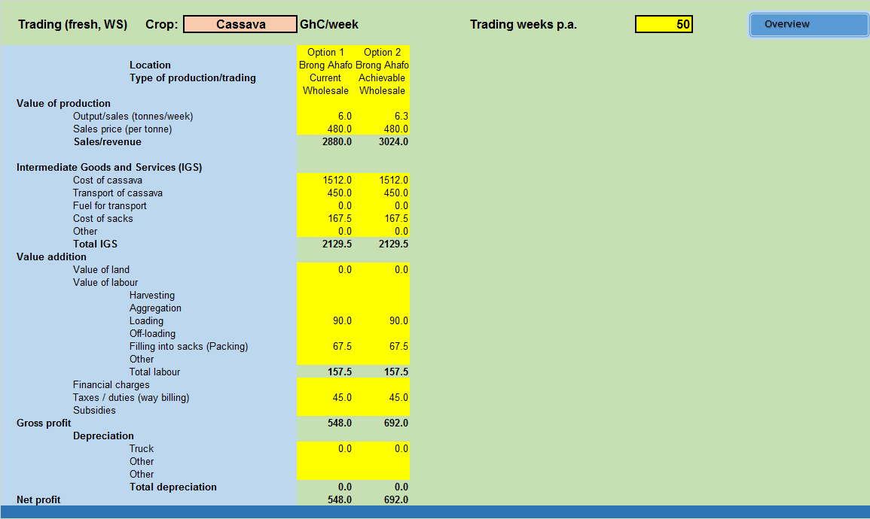
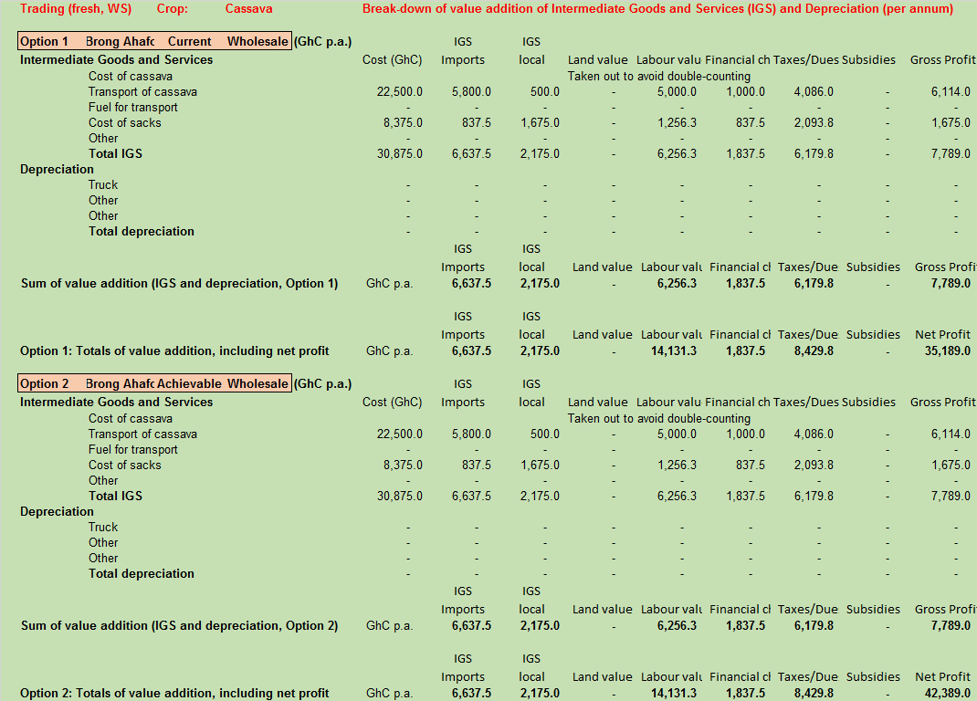
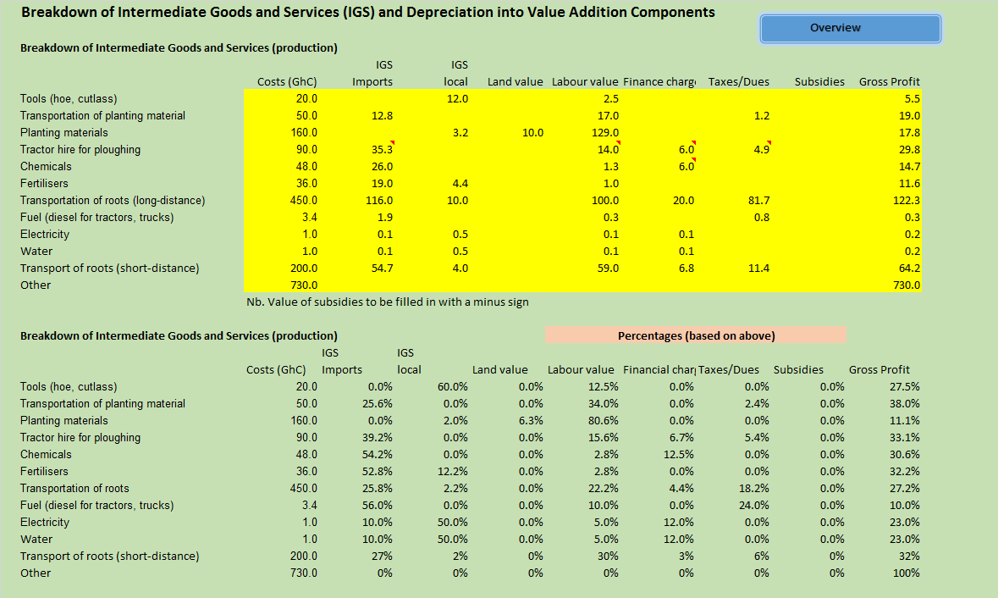
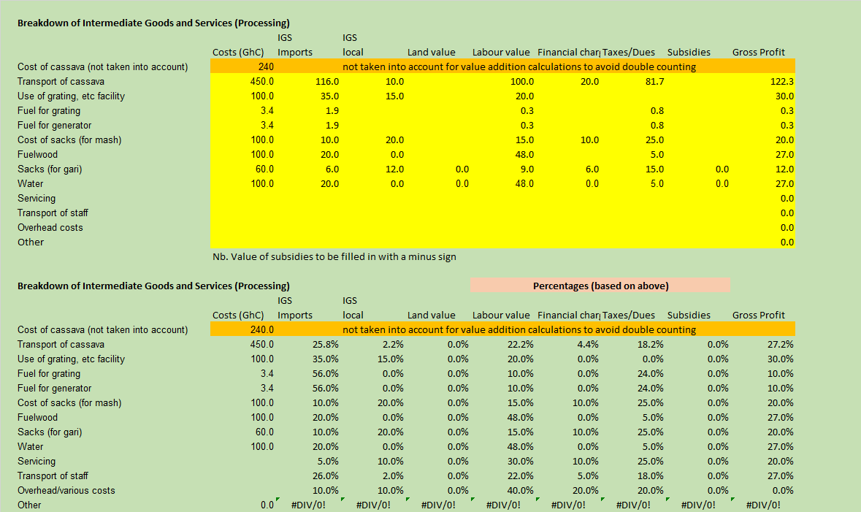
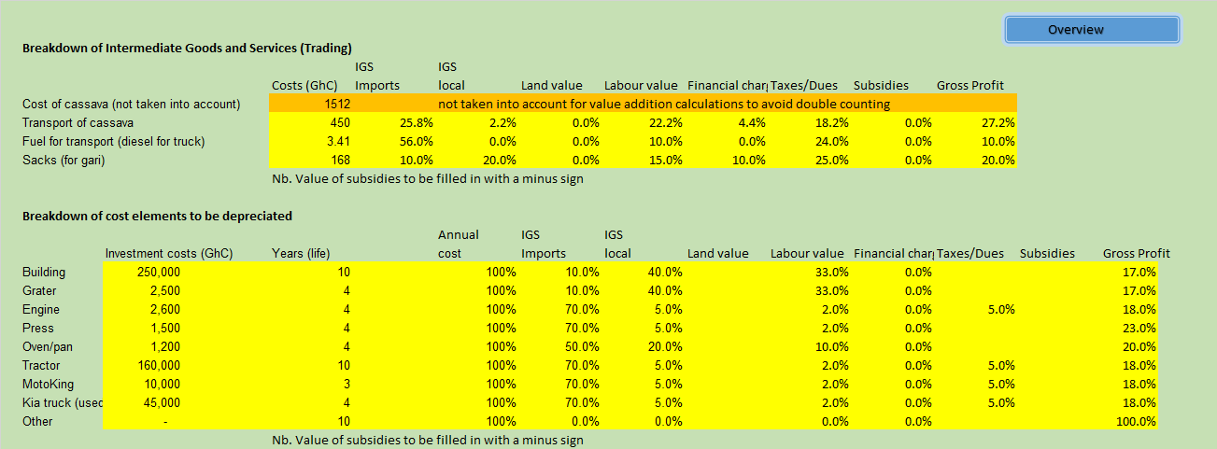

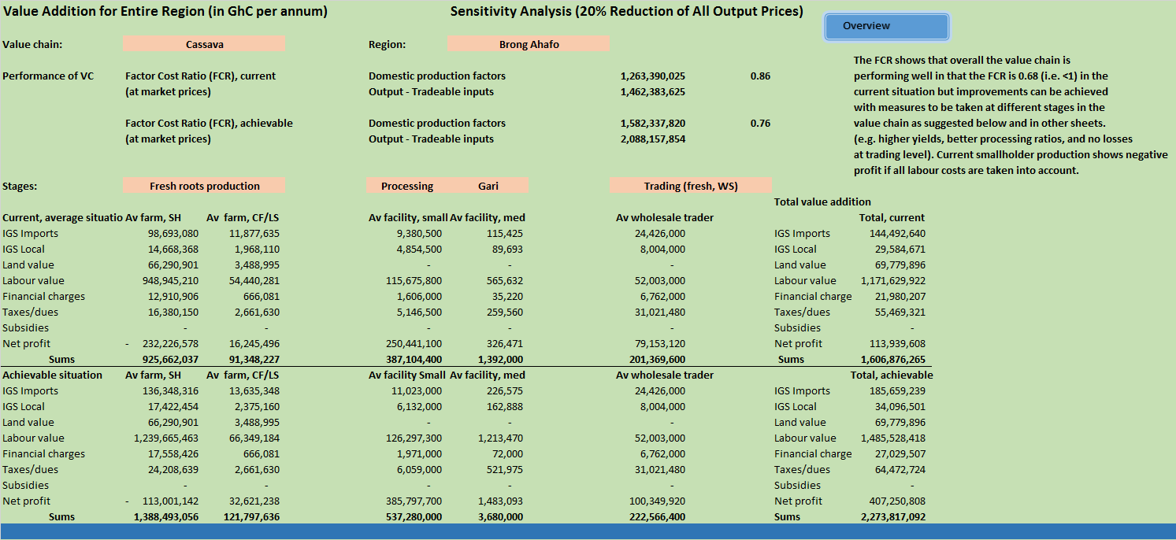
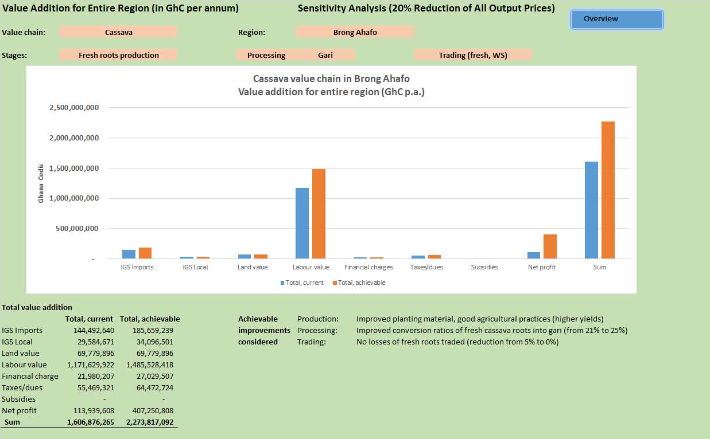

Appendix 5: Selected slides of presentation at GASIP Offices, May 2016

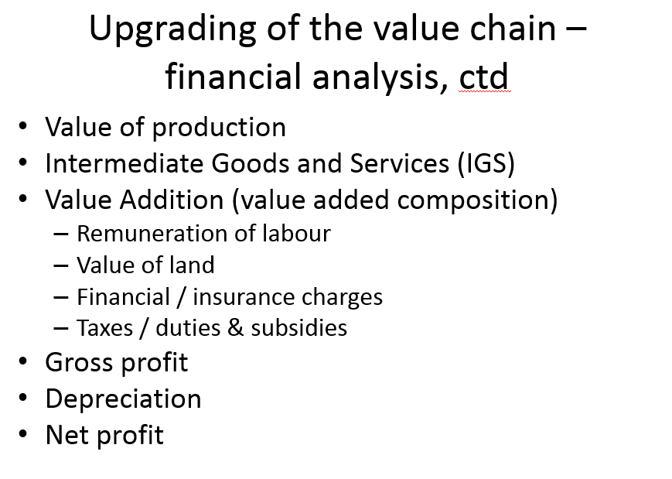

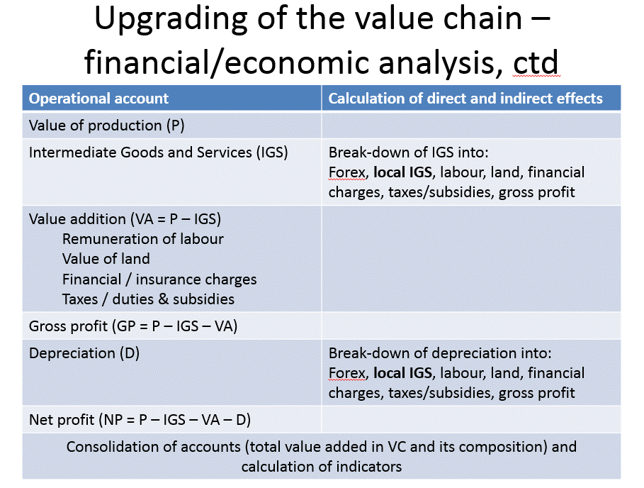

Regional Analytical Report: Brong Ahafo Region. Ghana Statistical Service, June, 2013. The section on Brong Ahafo Region is based on this publication.
2010 Population and Housing Census, Regional Analytical Report: Brong Ahafo Region. Ghana Statistical Service, June, 2013.
The Regional Director, Brong Ahafo Region (April 2016) Review Meeting Presentation, Kumasi, Ministry of Food and Agriculture.

